

What Is The Greatest Scientific Fraud Of All Time?

https://www.manhattancontrarian.com/blog?tag=Greatest+Scientific+Fraud
Table of Contents
What Is The Greatest Scientific Fraud Of All Time? 1
What Is The Greatest Scientific Fraud Of All Time? 3
What Is The Greatest Scientific Fraud Of All Time? -- Part II 6
The Greatest Scientific Fraud Of All Time -- Part III 8
The Greatest Scientific Fraud Of All Time -- Part IV 10
The Greatest Scientific Fraud Of All Time -- Part V 12
The Greatest Scientific Fraud Of All Time -- Part VI 15
The Greatest Scientific Fraud Of All Time -- Part VII 18
The Greatest Scientific Fraud Of All Time -- Part VIII 21
The Greatest Scientific Fraud Of All Time -- Part IX 23
The Greatest Scientific Fraud Of All Time -- Part X 26
The Greatest Scientific Fraud Of All Time -- Part XI 28
The Greatest Scientific Fraud Of All Time -- Part XII 31
The Greatest Scientific Fraud Of All Time -- Part XIII 35
The Greatest Scientific Fraud Of All Time -- Part XIV 37
The Greatest Scientific Fraud Of All Time -- Part XV 40
The Greatest Scientific Fraud Of All Time -- Part XVI 43
The Greatest Scientific Fraud Of All Time -- Part XVII 46
The Greatest Scientific Fraud Of All Time -- Part XVIII 48
The Greatest Scientific Fraud Of All Time -- Part XIX 52
The Greatest Scientific Fraud Of All Time -- Part XX 55
The Greatest Scientific Fraud Of All Time-- Part XXI 60
The Greatest Scientific Fraud Of All Time -- Part XXII 63
The Greatest Scientific Fraud Of All Time -- Part XXIII 67

What Is The Greatest Scientific Fraud Of All Time?
Being a fan of scientific fraud and of human depravity generally, I can come up with lots of nominations in this category. If you'd like to be reminded of some of the great ones that you have undoubtedly read about at some time or other, here is a Top Six list from Cracked, and hereis a Top Ten list from Listverse. They definitely have some memorable ones, from Jan Hendrik Schon, the rising star at Bell Labs who faked results for some twelve papers published in Science and Nature around the year 2000; to the fake "Tasaday" primitive tribe promoted by a Philippine government minister named Elizalde in the 1970s; to the archeological "discoveries" (planted) of Shinichi Fujimura in Japan in the 1980s; to Ranjit Chandra, who published studies on nutritional allergies of infants, blessing the baby formula products of Nestle and J&J (the studies were never conducted); etc., etc. One of the greatest frauds, making both lists, is the "Piltdown Man" missing link hoax of Charles Dawson in 1912.
But going through these lists also makes clear that none of these frauds comes close to the big one going on right now, which is the world temperature data tampering fraud. This is the fraud by which U.S. government agencies "adjust" temperatures of the past downward in order to make it seem like more recent years are warmer, and thus support the global warming narrative. Now you are going to say, that seems completely ridiculous, they couldn't possibly get away with it, and nobody in their right mind would try such a thing. Well, I'll just give you some evidence, and you decide.
The latest news comes from Joe D'Aleo of the ICECAP website, who reports on a new online tool available from NCDC. That's the National Climatic Data Center of Asheville, NC -- a Federal agency, part of NOAA, in turn part of the Commerce Department. NCDC is headed by Tom Karl, a serious global warming zealot. NOAA has been until recently headed by Jane Lubchenco, another serious global warming zealot. The new tool enables plotting temperature data for cities, states, or regions. So D'Aleo tried plotting the data for New York's Central Park for July, going back to 1885. Meanwhile he happened to know that the National Weather Service (another part of NOAA) had archived data for Central Park for the same time period, so he took the archived NWS data and the new NCDC data and plotted them on the same graph. Result:
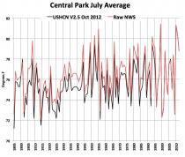
Enlarged version. Hmmmm. In the new version, the warm years of the 1930s have magically become cooler, thus making the most recent years much warmer by comparison.
D'Aleo then calculated the differences between the previous raw data and the new adjusted data. Here is that chart:
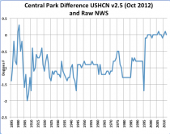
Enlarged version. Hmmmm again. From 1995 to present, the raw and adjusted temperatures are about the same, but before 1995 the temperatures are "adjusted" downward by between 0.5 and 1.5 deg C all the way back to the beginning of the century. What's going on here? And the amazing thing is, they don't say.
OK, you're thinking, this is some kind of strange anomaly, not a great fraud. Well, you need to get a little deeper into the subject. The main keeper of the official temperature records of the U.S. is a part of NASA called GISS (Goddard Institute for Space Studies), headed for decades by the recently (April 2013) retired James Hansen, another serious global warming zealot. GISS puts out charts of U.S. temperatures plotted on an annual basis. The funny thing is, those charts have changed over time. Here we have the 1999 and 2011 GISS versions of U.S. temperatures:
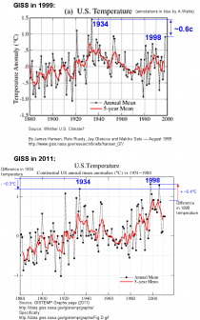
Enlarged version. In 1999 the 1930s were much warmer than 1998, but by 2011, 1998 had become much warmer than the 1930s. How could that possibly be? Lots and lots of people have noticed this, and have tried to get an explanation, but none is forthcoming.
Meanwhile, is there any significance to this? Well, just to take a small example, in his 2012 State of the Union speech, President Obama, latched on to the recently adjusted NASA data to proclaim:
For the sake of our children and our future, we must do more to combat climate change. Now, it’s true that no single event makes a trend. But the fact is, the 12 hottest years on record have all come in the last 15. Heat waves, droughts, wildfires, floods – all are now more frequent and more intense.
In the speech, Obama specifically cited to the recently adjusted NASA data. You can easily see by looking at the charts that the business of the "12 hottest years on record have all come in the last 15" was completely created by the unexplained NASA adjustments that occurred in 2011. Before the adjustments, many of the hottest years were in the 1930s.
Again, is it just an anomaly or quirk, or is there some kind of systematic fraud going on? A guy named Steven Goddard runs a web site called Real Science. He makes a cottage industry out of keeping track of archived temperature data and reporting on when the government-paid global warming activists adjust the old data downward. Input the word "tampering" into his search function, and you come up with literally dozens of examples where Goddard has identified earlier temperatures being adjusted downward to make the present appear warmer by comparison. The culprits are almost always NCDC and NASA/GISS, although every once in a while the WMO gets in on the act.
The charts at issue here are the very government charts that are used to support efforts to transform our energy economy and reallocate literally trillions of dollars of wealth and income. The allegations of data tampering are not frivolous -- they are supported by clear prima facie evidence. If there were a reasonable explanation, the government should have come out with it a long time ago. As far as I'm concerned, the case for fraud has been proved. There isn't any scientific fraud that I know of that comes remotely close.

What Is The Greatest Scientific Fraud Of All Time? -- Part II
Just under a year ago, on July 19, 2013, I asked the question, What Is The Greatest Scientific Fraud Of All Time? After going through a number of candidates (e.g., the Tasaday, Piltdown Man) I concluded:
[G]oing through these lists also makes clear that none of these frauds comes close to the big one going on right now, which is the world temperature data tampering fraud.
The world temperature data tampering fraud is the fraud whereby the official U.S. government guardians of temperature data, namely NOAA/NCDC and NASA/GISS, systematically adjust older temperatures down and newer temperatures up in order to introduce spurious warming trends into the data and thereby support the narrative that "global warming" is occurring.
Some people who are following and reporting on this story are still avoiding the use of the word "fraud." I am not.
When I wrote the July 2013 post, this story was still struggling for attention. A very energetic guy who blogs at Real Science under the name Steven Goddard (actual name: Tony Heller) was writing post after post comparing recent temperature data on government websites to previous versions, and noting example after example of downward adjustments of the past and upward adjustments of the more recent data. However, some had criticized his work for occasional inaccuracies or errors. Joseph D'Aleo of the icecap.us website had also entered the fray with several examples of unexplained adjustments. But otherwise the story has been largely quiet in the intervening year.
That all ended a couple of weeks ago. Over a period of a few days, several wide circulation sites, and even a television news show, featured some of Goddard's work. It had lead position on Drudge for a day. Steve Doocy of Fox and Friends had a segment based on Goddard's work where he stated "NASA scientists fudged the numbers to make 1998 the hottest year to overstate the extent of global warming." Other sources picking up the story included the Telegraph, Breitbart, and realclearpolitics.
Next, politifact decided to weigh in. They went to the usual suspects of the "mainstream" climate community, including the director of NASA/GISS, Gavin Schmidt. These usual suspects engaged in the usual obfuscatory handwaving, attributing various of the adjustments to seemingly legitimate things like station moves and changes in the time of day at which thermometers are read. Politifact fell for it, rating Doocy's Fox News piece "pants on fire."
But by this time the story was getting so much play that lots of people were starting to pay attention. A guy named Paul Homewood of the website notalotofpeopleknowthat was intrigued enough to pick one station at random in Texas and do a deep dive into the data. His resulting post on June 26 is titled "Massive Temperature Adjustments at Luling, Texas." His conclusion:
[T]he adjustments have added an astonishing 1.35C to the annual temperature for 2013. Note also that I have included the same figures for 1934, which show that the adjustment has reduced temperatures that year by 0.91C. So, the net effect of the adjustments between 1934 and 2013 has been to add 2.26C of warming.
Then Joe D'Aleo weighed in with some data from Maine. In 2013 he had downloaded NCDC annual temperature data for Maine. Then NOAA earlier this year announced a transition to a new so-called CLIMDIV version of its USHCN data for Maine, so D'Aleo downloaded that for comparison to the version he had downloaded last year. How did the two compare? While the old data showed no warming in a record going all the way back to 1895, suddenly there was a large warming trend. And where did it come from?
The new CLIMDIV data was supposed to resolve issues with recent station moves, transition to airport, to new MMTS technology and UHI and siting issues with improvements late in the record, we were very surprised to see the biggest changes to the early data set. 1913 went from the warmest year in the record to the middle of the pack with a cooling of close to 5F!.
So kindly, Dr. Schmidt, can you explain exactly how a change to the time of day at which temperatures are read has now made 1913 5F cooler in Maine than it was previously?
On June 28 the highly respected Judith Curry of Georgia Tech weighed in with a post titled Skeptical of skeptics: is Steve Goddard right? I have previously noted that Curry, once a member of the climate science in crowd, has become increasingly unaccepting of the unscientific antics of the climate science community. Her conclusion after reviewing Goddard, Homewood and others:
I infer from this that there seems to be a real problem with the USHCN data set, or at least with some of the stations. . . . As far as I can tell, NOAA has not responded to Goddard’s allegations. Now, with Homewood’s explanation/clarification, NOAA really needs to respond.
On June 29, there was a lengthy post by Anthony Watts of wattsupwiththat, titled NOAA's temperature control knob for the past, the present, and maybe the future - July 1936 now hottest month again. Anthony did some looking at yet more data, and every place you look the story comes up the same. For example, Anthony asked a guy named Bruce at Sunshine Hours to gather data on Kansas and plot it on some maps, which then appear in Anthony's post. Example of the results:
Bruce also plotted some other maps of Kansas, for July 1936, and for July 2012. Note how in July 1936 the Tmax temperature are almost all adjusted cooler, and in 2012, most all Tmax temperatures are adjusted warmer.
Go to Anthony's post for the maps with station by station data. Anthony then asks: Whatever happened to just using actual measured data? There is no justification for this.
But at the end of his post, Anthony continues to give these people the benefit of the doubt:
I don’t believe this is case where somebody purposely has their hand on a control knob for temperature data, I think all of this is nothing more than artifacts of a convoluted methodology and typical bureaucratic blundering. As I’ve always said, never attribute malice to what can be explained by simple incompetence.
Sorry, but I'm not buying it. Here are my problems: (1) Adjustments to the raw data are everywhere, and literally all of them make the past cooler and the present warmer. (2) There are literally tens of billions of dollars at stake in having a record of increasing temperatures. Every scientist working in the "climate science" area is dependent on continuation of government science funding in this area totaling as much as $10 billion per year. Then there are additional massive subsidies for things like green energy. (3) They won't release all the underlying calculations and computer code behind the adjustments. My conclusion: There is nothing innocent about this. This is the IRS deleted emails scandal multiplied by a factor of 100.
Politifact put a series of questions about this to NCDC and Watts has also posted their response here. The heart: "our algorithm is working as designed." No backup, no code, no detailed justification of each change. And good luck trying to get that.
Repeat: The Greatest Scientific Fraud Of All Time.

The Greatest Scientific Fraud Of All Time -- Part III
A few weeks ago, in mid-January, you would have had a hard time missing the big shouting and celebration in the global warming alarmist camp of 2014 being the "hottest year ever." As just a few examples, there was Scientific American on January 5 ("2014 Officially Hottest Year On Record"); the BBC on January 16 ("2014 warmest year on record, say US researchers"); or the New York Times on January 16 ("2014 Breaks Heat Record, Challenging Global Warming Skeptics"). There were plenty of others like those.
If you read all of those articles, without doubt you will come away asking yourself one glaring question, namely: So what did the satellites show? Not one of these articles, or for that matter any of many others from the alarmist camp that I have looked at, so much as mentions the satellite data. But anybody who follows this issue even a little knows that beginning in 1979 the U.S. government at great taxpayer expense has put up satellites with sophisticated instruments to get much more accurate measurements of world temperatures than previously available. The alternative networks of ground based thermometers still exist, but have widely scattered coverage and are subject to large inaccuracies (like from having cities grow up around them, or having their sites moved over the years). So SA, BBC, NYT: How could you insult our intelligence with articles trumpeting "hottest year ever" without telling us what the satellites say?
Luckily it's not too hard to figure out what the satellites say -- their data is published monthly by two sources, UAH and RSS. Here's an article summarizing the results from both. Of course it's exactly what you knew it would be as soon as you saw that the likes of the liars at SA, BBC and NYT wouldn't tell you what the satellites say: 2014 was not the hottest year, nor close, but rather tied for 6th/7th place in the 36 year record from RSS, 0.3 degrees C cooler than the warmest year, which was 1998 -- 16 years ago. Now 0.3 degrees C may not be a lot, but it's also not a little in a record that only varies by about 1.2 degrees C from coolest to warmest year.
But it gets worse. Regular readers of this blog know that there is a gigantic issue out there of the extent to which the ground thermometer records can be trusted because the guardians of the data (who are the same people putting out the press releases about 2014 being the "hottest year ever") have been systematically tampering with the data to make the earlier years cooler and therefore make the present appear warmer by comparison. I previously wrote about this issue on July 3, 2014 ("What Is The Greatest Scientific Fraud Of All Time -- Part II") and on July 19, 2013 ("What Is The Greatest Scientific Fraud Of All Time?") Those articles name names, both of the crooked U.S. government paid fake scientists who "adjust" the raw thermometer data without explanation to fit the desired narrative of "hottest year ever," and also of the independent researchers who laboriously track down old archived temperature records to uncover the tampering.
Just today this issue is starting to explode. It was at the top of Drudge earlier today, although now gradually falling back. Drudge linked to an article by Christopher Booker in the UK Telegraph from Saturday titled "The fiddling with temperature data is the biggest science scandal ever." (Wait, are they stealing their headlines from me? OK, not quite.) Booker discusses the work of Paul Homewood, reported on his blog notalotofpeopleknowthat. Sample (from Booker):
Homewood has now turned his attention to the weather stations across much of the Arctic, between Canada (51 degrees W) and the heart of Siberia (87 degrees E). Again, in nearly every case, the same one-way adjustments have been made, to show warming up to 1 degree C or more higher than was indicated by the data that was actually recorded. This has surprised no one more than Traust Jonsson, who was long in charge of climate research for the Iceland met office (and with whom Homewood has been in touch). Jonsson was amazed to see how the new version completely “disappears” Iceland’s “sea ice years” around 1970, when a period of extreme cooling almost devastated his country’s economy.
Homewood has also uncovered massive tampering from Paraguay. John Hinderaker of Power Line includes numerous animated GIFs from Homewood demonstrating the data tampering from Paraguay. Homewood adds his work to the extensive output of Tony Heller (who blogs under the name Steven Goddard) of realscience. Heller has uncovered and reported on data tampering at dozens of sites. Just today he reports on Addison, New York. In every instance, whether Siberia, Paraguay, or upstate New York, it's always the same thing -- the past has been cooled to make the present look warmer by comparison. But how could the past somehow have suddenly gotten cooler, 50 or 80 or 100 years after the fact?
Lots and lots of people have demanded an explanation from the guys at NCDC/GISS who put out the adjusted/tampered data and then claim "hottest year ever." They won't give any.
So, Scientific American, BBC, New York Times, and all the rest of you who uncritically report the greatest scientific fraud of all time as if it was the truth: When are you going to tell us the real story?

The Greatest Scientific Fraud Of All Time -- Part IV
As discussed here in three previous posts, over the past few years, several independent researchers have laboriously compared raw archived temperature data at numerous stations with adjusted data used by U.S government agencies NASA/GISS and NOAA/NCDC in calculating world temperatures and making declarations of "hottest year ever." The researchers have included Tony Heller of the Real Science web site, Paul Homewood of Not a Lot of People Know That, and Joe d'Aleo of ICECAP. In examination of data from scores of weather station sites, they have uniformly found that the adjustments have been to cool temperatures in older years and warm temperatures in later years, thereby creating or adding to a warming trend that does not exist in the raw data. Many of the adjustments have been significant -- 1 deg C or more -- and some have approached 3 deg C. The web sites in question contain links to the raw and adjusted data used in the calculations, so anyone with knowledge of any particular site could come forward and say, for example, that the raw data they are using for Reykjavik is wrong, or the adjustment for 1932 is justified by a move of the site from point A to point B in that year, or some such thing.
But I can't find any such challenges to the work of these researchers. In fact, most remarkable to me is the almost total silence from GISS and NCDC. As I mentioned in my July 2014 post, politifact had put a series of questions to NCDC on the subject of some specific adjustments at sites in Kansas and Texas, and their response can be found here. The response is extremely terse and the key quote is "our algorithm is working as designed." Judith Curry of Georgia Tech and the Climate Etc. site had said that "NOAA really needs to respond." But we get nothing in the way of specific justification for any adjustment, no code, no explanation.
Looking around in the last couple of days for any kind of response to very credible allegations, the closest I can find is a post from some scientists at Berkeley Earth that appears at Ms. Curry's web site. Berkeley Earth, for those unfamiliar, claims to be an "independent" organization, and is run by father and daughter Richard and Elizabeth Muller. They publish their major funders on their web site, and you can see that they have received significant amounts from the U.S. government, but more from various foundations, and they are not a U.S. government agency. Muller father claims to be a former climate skeptic who converted. I can't find any good evidence that he was ever a skeptic, and I would call him a global warming activist, but I'll let you do your own research and form your own conclusion.
Anyway, the Berkeley Earth response, dated February 9, appears at first blush to be long, detailed and technical. But I would call it hand-waving. The gist is, we've looked at these accusations and there's really nothing to them because overall they don't add up to any meaningful change in the overall world temperature series, so there's really nothing here. Trust us. Key quotes:
In general, noise and inhomogeneities in temperature data will make a temperature field rougher while homogenization practices and spatial averaging will make it smoother. Since the true temperature distribution is unknown, determining the right amount of homogenization to best capture the local details is challenging, and an active area of research. However, as noted above, it makes very little difference to the global averages.
In summary, it is possible to look through 40,000 stations and select those that the algorithm has warmed; and, it’s possible to ignore those that the algorithm has cooled. As the spatial maps show it is also possible to select entire continents where the algorithm has warmed the record; and, it’s possible to focus on other continents were the opposite is the case. Globally however, the effect of adjustments is minor. It’s minor because on average the biases that require adjustments mostly cancel each other out.
OK, I'm in the litigation business, and that goes exactly nowhere with me. Specific allegations demand a specific response, and no judge or jury I've ever been before would take this as a credible answer to the charges. Here are some specific questions that must be answered or no one who pays attention is going to believe a word you are saying:
- For each station where the independent researchers have demonstrated that adjustments have created or added to the warming trend, give us a specific justification for the adjustment. That justification must also support the specific magnitude of the adjustment. For example, what is the specific justification for adjustments coming to 2.26 deg C for Luling, Texas, or 5 deg F (2.6 deg C) for the state of Maine?
- You say that there are stations where the adjustments go in the opposite direction and that the total of all adjustments essentially cancels out. OK then, give us a list of stations where the adjustments go in the opposite direction, and enough of them with large enough quantitative adjustments to cancel out what the researchers have presented. How come nobody but you knows about them?
- Numerous adjustments have been identified that cool the past by multiple degrees, often 50 to 100 years after the fact. I can't think of any possible justification for this, and I'm not alone. Let's hear it!
- Address the arctic specifically. I note that a huge percentage of your warming trend has taken place in the arctic (north of 65N) and Homewood has attempted to go through all of those stations and has found uniform large adjustments to increase warming and not a single one in the other direction. Instead of addressing the arctic, you address "selected regions", leaving out Siberia and Canada entirely and blending the remainder with sub-arctic areas. Don't think we don't notice tricks like this!
- Let's see the code for your "homogenization" algorithm.
The Berkeley Earth post suggests that they may be coming forth with some of this information at some point in the future. We're eagerly awaiting it. In the current state of affairs, I would say that Goddard, Homewood, d'Aleo, et al. are way ahead.

The Greatest Scientific Fraud Of All Time -- Part V
Scientific fraud has been all over the news this past week. The latest example is an article titled "When contact changes minds: An experiment on transmission of support for gay equality," by Michael LaCour and Donald Green, that appeared in Science back in December. The LaCour/Green article reported on a study in which it was claimed that people's attitudes toward gay marriage were significantly changed following discussions of about 20 minutes in length with door-to-door canvassers. When the article came out, it created a mini media sensation, with discussion in outlets including the New York Times, Washington Post, Wall Street Journal, Los Angeles Times, The Economist, and others. Really, it's just remarkable how all BS radar gets turned off when a new study reports what the right people want to hear.
The unraveling began on May 19 when a critique of LaCour/Green titled "Irregularities in LaCour (2014)" appeared on the website of Stanford University, written by David Broockman and others. Trying to replicate and extend LaCour's results, Broockman and his co-authors uncovered serious irregularities in the LaCour data. They presented the information to Green, who then asked that the article be retracted. LaCour claims to stand by his data, but -- oops -- it has been deleted. And thus this past week we are treated to long philosophical essays on scientific fraud from the likes of NYT and WSJ.
I have to admit that in the world of scientific frauds, this is a pretty good one. Then again, compared to the Big One, this is pretty small time. By the Big One, I am of course referring to the world temperature data tampering fraud, by which 50 and 100 year old temperature records are systematically altered to make them cooler, thus exaggerating the extent of warming and keeping the "global warming" narrative going. Anything new on that one this week?
As a matter of fact, there is. On Thursday June 4, Science came out with an article by Thomas Karl and multiple co-authors titled "Possible artifacts of data biases in the recent global surface warming hiatus." Yes, it's the same Science that also published the discredited LaCour article. This article is an attempt to deal with the now-famous global warming "pause" or "hiatus," in which world temperatures, as measured by multiple data sets including the highly accurate satellites, have refused to increase for a period now exceeding 18 years, in the face of predictions of disaster coming out of the UN IPCC and others. Tom Karl, for those who don't recognize the name, is a high-ranking bureaucrat at NOAA and a serious global warming alarmist. Here's the abstract of the article from Science:
Much study has been devoted to the possible causes of an apparent decrease in the upward trend of global surface temperatures since 1998, a phenomenon that has been dubbed the global warming “hiatus.” Here we present an updated global surface temperature analysis that reveals that global trends are higher than reported by the IPCC, especially in recent decades, and that the central estimate for the rate of warming during the first 15 years of the 21st century is at least as great as the last half of the 20th century. These results do not support the notion of a “slowdown” in the increase of global surface temperature.
You see, we have just "updated" the "global surface temperature analysis." No big deal in that. And of course the updating "reveals" that temperatures are increasing faster than anyone thought!
Needless to say, the New York Times immediately picked up the story and reported it as fed to them by Karl, without any critical thinking of any kind. The article on June 4 is by climate-activist-masquerading-as-reporter Justin Gillis, and titled "Global Warming 'Hiatus' Challenged By NOAA Research." Excerpt:
Scientists have long labored to explain what appeared to be a slowdown in global warming that began at the start of this century as, at the same time, heat-trapping emissions of carbon dioxide were soaring. The slowdown, sometimes inaccurately described as a halt or hiatus, became a major talking point for people critical of climate science. Now, new research suggests the whole thing may have been based on incorrect data. When adjustments are made to compensate for recently discovered problems in the way global temperatures were measured, the slowdown largely disappears, the National Oceanic and Atmospheric Administration declared in a scientific paper published Thursday.
So, Tom and Justin, can you kindly explain how you have managed to make temperatures of the past get cooler in order to make it appear that there is a warming trend where none previously existed in multiple data sets? The problem they have is that now lots of credible scientists are immediately all over their work, and before the week was out everybody who follows this knew how the trend got altered. By the end of the week we had "A First Look at ‘Possible artifacts of data biases in the recent global surface warming hiatus’ by Karl et al., Science 4 June 2015," by Ross McKitrick; "Has NOAA ‘busted’ the pause in global warming?" by Judith Curry; "@NOAA ‘s desperate new paper: Is there no global warming ‘hiatus’ after all?" by Patrick Michaels, Richard Lindzen and Paul Knappenberger; and "Reports of the death of the global warming pause are greatly exaggerated," from the Global Warming Policy Foundation. The last is the least technical, so I'll quote from their list of obvious points:
* The authors have produced adjustments that are at odds with all other surface temperature datasets, as well as those compiled via satellite.
* They do not include any data from the Argo array that is the world’s best coherent data set on ocean temperatures.
* Adjustments are largely to sea surface temperatures (SST) and appear to align ship measurements of SST with night marine air temperature (NMAT) estimates, which have their own data bias problems.
* The extent of the largest SST adjustment made over the hiatus period, supposedly to reflect a continuing change in ship observations (from buckets to engine intake thermometers) is not justified by any evidence as to the magnitude of the appropriate adjustment, which appears to be far smaller.
And by the way guys, how about the data from the satellites? Anyway, for Karl, Gillis, et al., it's all very simple: pick one data set that you like, even though everyone knows it has big gaps and inaccuracies, and adjust all other and better data to that one to fit your narrative. The President will be proud!
And in other climate-related news, President Obama wanted to talk to famed environmental documentary-maker Richard Attenborough, so on the spur of the moment he had Attenborough flown over from London to "chat" about climate change. According to this report at Slate,Attenborough said he was "baffled" about why the President wanted to talk to him. And don't worry, the carbon footprint of that trans-Atlantic roundtrip doesn't count, because it was for Obama. Also, by the way, the carbon footprint of that flight was teensy compared to the one laid down by John Kerry. That's the guy who has declared global warming to be the biggest security risk to the United States, bigger than Iran and ISIS. After breaking his leg riding his bicycle in France, Kerry was flown home from Geneva. Here's a picture of the plane he flew home in -- a C17. Hey, it's smaller than a 747!


The Greatest Scientific Fraud Of All Time -- Part VI
It's been over a month since I wrote an update on "The Greatest Scientific Fraud Of All Time," so it's time to check in on it again. For those not following this, the fraud in question is the world temperature data tampering fraud, by which the keepers of historical world temperature records adjust temperatures in earlier years downwards in order to create or enhance warming trends and support the narrative of catastrophic global warming. The principal perpetrators of the fraud are U.S. government employees in the agency known as NOAA (National Oceanic and Atmospheric Administration).
Readers of the previous articles know that NOAA has been caught red-handed over and over adjusting earlier temperatures downward. They uniformly provide no explanation beyond something like "our homogenization algorithm is working appropriately," refuse to give any details, and expunge the earlier raw data to make it as hard as possible for anyone to prove the fraud. My previous articles are here, here, here, here and here.
Numerous examples of NOAA's pervasive and unexplained adjustments have been published on websites including ICECAP, RealScience, NotaLotofPeopleKnowThat, WattsUpWithThat and others. And numerous independent researchers have done a lot to thwart NOAA's data deletion efforts by archiving earlier versions of the data. You can't follow this issue at all without knowing that there are very credible and thoroughly demonstrated instances of pervasive data tampering by NOAA. You also can't follow this issue at all without knowing that there are several other independent data sets, most notably the two satellite data sets of UAH and RSS covering the period 1979 to present, that do not show the warming that the NOAA data shows.
And yet, with this background, NOAA keeps putting out press releases, more or less monthly, trumpeting alleged new high temperature records, and supposed "news" outlets pick up the releases and put out stories with one scary headline after another, never mentioning that other data sets do not show the same records or warming, and never mentioning that serious and thoroughly-proved allegations of data tampering have been made against NOAA and never refuted.
Not meaning to pick specifically on Bloomberg News, but their website front page has made a point for several months of having a global warming scare headline up there at nearly all times. For example, today there is "World Breaks Temperature Records As Climate Summit Nears." ("Global land and sea surface temperatures from January through June were 1.53 degrees Fahrenheit above the 20th century average, the highest since recordings started in 1880, the National Oceanic and Atmospheric Administration said in a report.") Yesterday it was "Monster El Nino Makes Record Hot Year Look Inevitable." ("This has been the hottest start to a year by far, according to data released today by the National Oceanic and Atmospheric Administration.") Or try June 18, "This Year Is Headed For The Hottest On Record, By A Long Shot." ("Last month was the hottest May on record, and the past five months were the warmest start to a year on record, according to new data released by the National Oceanic and Atmospheric Administration.") Or April 17: "Global Temperature Records Just Got Crushed Again." ("March was the hottest month on record, and the past three months were the warmest start to a year on record, according to new data released by the National Oceanic and Atmospheric Administration.") Notice that every time the source is specifically NOAA, without any mention of other data sets that do not show the same thing, nor any mention of the well-established allegations of data tampering against NOAA. Pathetic.
Believe me, Bloomberg is not the only one. To give just a couple of examples, here is NBC News from yesterday, "Another Month, Another Global Heat Record Broken." ("Off-the-charts heat is "getting to be a monthly thing," said Jessica Blunden, a climate scientist for the National Oceanic and Atmospheric Administration. June was the fourth month of 2015 that set a record, she said.") Or the New York Times from March 18, "Winter Sets Global Heat Record Despite US East's Big Chill." ("Federal [NOAA] records show that this winter and the first two months of 2015 were the hottest on record globally, with a chilly U.S. East sticking out like a cold thumb in a toastier world.") Always NOAA and only NOAA. Never any mention of other data sets or what they show. Never any mention of known NOAA data tampering.
A website called NoTricksZone has a good roundup today comparing the latest NOAA data showing supposed "records" with data from the other independent (and also more accurate) satellite data sets. It's just as you'd expect:
NOAA claims that the global surface temperature reached a new all-time record high with an anomaly +0.88°C – the warmest since recordkeeping began in 1880! However measurements taken by satellite Remote Sensing Systems (RSS) show that although June 2015 indeed was a warm month at +0.39°C, it was only the 4th warmest June ever, and more than 30 other earlier months have seen greater positive anomalies [in records going back to 1979] Satellite data (revised) [also data going back to 1979] taken by the University of Alabama in Huntsville UAH show that the June 2015 temperature anomaly was +0.31°C, a warm month but not the hottest June ever as three other June months were as warm or warmer. Moreover plots of the RSS and UAH data continue to show that global temperatures have been flat for now close to 20 years.
NoTricksZone then has the following comment from meteorologist Joe d'Aleo:
“The problem is that the same staff responsible for creating the reports about the climate . . . and running some of the greenhouse models that project the scary scenarios . . . are also responsible for the databases that validate the forecasts. . . . There is a lot of control available for modelers to predict a desired result, and data source inconsistencies allow NOAA to be creative – and the result is a hybrid of data and models (with their adjustments like TOA, infilling and homogenization) to show whatever the puppet-masters in government require. It may be that some really believe in their science and work hard to mine the data, achieving a form of bias confirmation. In other cases it is ideologically or politically driven or a matter of job security.”
Also at NoTricksZone from a couple of weeks ago (July 7) is the latest discovery of yet another example of widespread NOAA data tampering. A guy named Michael Brakey is an energy consultant in Maine, and for his job had reason to archive older temperatures to keep track of how his home efficiency solutions were working. To his amazement, on repeated visits to NOAA's website to collect data, he found that older temperatures had been systematically altered downward:
In early 2015, I revisited the NOAA website and updated my HDD [heating degree day] and cooling degree-day (CDD) data for a local television presentation. Here I was shocked to discover that NOAA had not only rewritten Maine climate history for a second time in the last 18 months, but with all the tinkering they also screwed up southern interior Maine averages.
There's lots more detail at the link, including additional discovery of massive data tampering with archived temperatures in Ohio and Tennessee. The tampering is always in the same direction -- earlier temperatures get cooler, thus enhancing warming trends, and making the latest data look like a "record."
Brakey asked NOAA to explain, and got this:
“…improvements in the dataset, and brings our value much more in line with what was observed at the time. The new method used stations in neighboring Canada to inform estimates for data-sparse areas within Maine (a great improvement).”
Replacing actual, observed temperatures in Maine with observations from "neighboring Canada" supposedly brings the value "more in line with what was observed at the time"? It couldn't be more preposterous. Bloomberg, NBC, New York Times, and the rest of you: do you realize the extent to which you are getting scammed? Or are you part of the scam? It's just beyond belief.

The Greatest Scientific Fraud Of All Time -- Part VII
With every passing month this just gets more and more bizarre.
So we're now deep into August, and the question on all of your lips has to be, where did July 2015 stack up in the world temperature history record books?
Checking first with the satellite records (that go back to 1979) we find that July 2015 was roughly a middling month. Recall that these satellite measurements are worldwide, taken in the lower troposphere, with each equal volume of air counted equally. Joe D'Aleo of the ICECAP website helpfully provided me this chart compiled from the UAH satellite data ranking the Julys of the last 20 years from warmest to coldest; July 2015 ranks ninth out of just these twenty, rather far behind number one, which is July 1998:
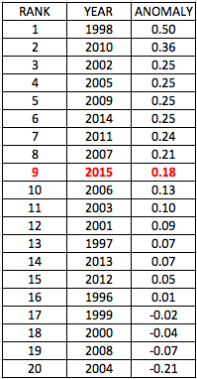
Checking next with US HCN (Historical Climate Network) data (going back to 1895 and covering just the U.S.) we find that July 2015 was again roughly a middling month. This data comes from a network of ground-based thermometers in the U.S. only. Tony Heller of the Real Climate Science website has compiled the data into this chart in which 2015 ranks 51st out of 120 years:
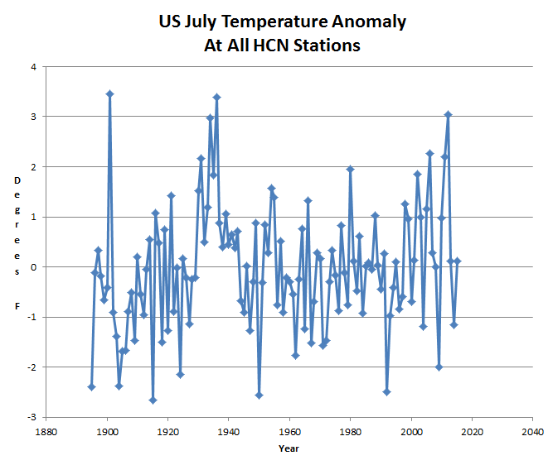
OK, dare we now check in with the guys at NOAA (National Oceanic and Atmospheric Administration)? Here is their release of July 2015 temperatures. These data are worldwide, again from a network of ground-based thermometers, although the density of coverage varies greatly from one area to the next. The data here have been "adjusted" by so-called "homogenization" algorithms, which the bureaucrats in charge refuse to disclose the details of. Key quote:
July 2015 was warmest month ever recorded for the globe. Global oceans record warm for July; January-July 2015 also record warm.
It's the hottest month EVAH! And remember, these are the guys who previously loudly proclaimed that May 2015 and March 2015 were the hottest March and May on record respectively.
So really, how could these different data sets be showing not just somewhat different, but wildly different results?
The increasing divergence between the UAH/RSS satellite records and the NOAA/GISS/HadCRUT thermometer records was the subject of a long comment posted at Watts Up With That in June by physicist Robert Brownof Duke University. That comment deserves quoting at some length:
The two data sets should not be diverging, period, unless everything we understand about atmospheric thermal dynamics is wrong. . . . [T]he growing difference is strong evidence of bias in the computation of the surface record. . . . [E]very new version of HadCRUT and GISS has had the overall effect of cooling the past and/or warming the present! This is as unlikely as flipping a coin (at this point) ten or twelve times each, and having it come up heads every time for both products. . . . If [the divergence between the data sets] grow[s] any more, I would predict that the current mutter about the anomaly between the anomalies will grow to an absolute roar, and will not go away until the anomaly anomaly is resolved.
In short, the divergence is just not plausible at this point. My only quibble with Brown is that he is way too nice in using the word "bias" to describe what is going on with the NOAA/GISS/HadCRUT data sets. I'm sorry, but there is no way this can be anything other than intentional reverse engineering to create an artificial warming trend. What the divergence does is make plain to anyone who cares to inquire that the entire trend of increasing temperatures reported by NOAA/NASA has been artificially created by their "adjustments," which they resolutely refuse to explain.
So how is this subject reported in the news media? CNN: "NOAA: July hottest month on record . . ."; no mention of satellite record or of divergence. The Weather Network: "Earth Just Had Its Hottest Month of ANY Ever Recorded"; no mention of satellite record or of divergence. Science Daily: "July 2015 was warmest month ever recorded for the globe"; no mention of satellite record or of divergence. USA Today: "July was Earth's hottest month ever recorded"; no mention of satellite record or of divergence. Slate: "July Was Earth's Hottest Month Ever Recorded"; no mention of satellite record or of divergence. LA Times: "July was warmest month on Earth in 136 years, NOAA says"; no mention of satellite record or of divergence. UN Climate Change Newsroom (OK, you knew you couldn't trust these guys): "July 2015 Hottest Month Ever Recorded"; no mention of satellite record or of divergence. Time: "July Was The Hottest Month Ever"; no mention of satellite record or of divergence. CBS News: "July was Earth's hottest month in recorded history"; no mention of satellite record or of divergence. Fortune: "July was the hottest month in the hottest year on record"; no mention of satellite record or of divergence. BBC: "July was Earth's hottest month on record, NOAA says"; no mention of satellite record or of divergence. ABC (Australia): "Global warming: World sweats over July breaking warmest month record, 2015 hottest year so far"; no mention of satellite record or of divergence. Washington Post: "July was the hottest month in Earth’s hottest year on record so far"; no mention of satellite record or of divergence. AP: "Feeling the heat: Earth in July was hottest month on record"; no mention of satellite record or of divergence. Reuters: "July was hottest month recorded worldwide: U.S. scientists"; no mention of satellite record or of divergence. The Independent (UK): "Climate change: July was the Earth's hottest month on record – while 2015 could be the warmest year, scientists say"; no mention of satellite record or of divergence. Bloomberg News: "July Was Earth’s Warmest Month in Records Going Back to 1880"; no mention of satellite record or of divergence.
Really, you could go on literally as long as you want with this. How stupid do these people think we are?
Brown predicted that the current "mutter" about the "anomaly between the anomalies" will shortly be turning into a "roar." It certainly should. Actually, it should have already. But remember that all the climate reporters at all those mainstream media outlets are perfectly aware of the satellite records and of the divergence between the satellite records on the one hand and the "adjusted" NOAA/NASA records on the other. And to a person they are intentionally suppressing any mention of the satellite records or of the divergence. It's remarkable, but it's how groupthink works. Anybody who mentions the actual facts is subject to being shamed, ostracized, and run out of the profession. See, Larry Tribe. The whole affair is an embarrassment to the profession of journalism.
To review parts I through VI of this series on "The Greatest Scientific Fraud Of All Time," go here.

The Greatest Scientific Fraud Of All Time -- Part VIII
In a prior piece in this series (Part V), I reported back on June 7 on an article that had just come out in Science titled "Possible Artifacts Of Data Biases In The Recent Global Surface Warming Hiatus." The article was written by a team of government scientists from the National Oceanic and Atmospheric Administration (NOAA) and the National Centers for Environmental Information (NCEI), led by one Thomas R. Karl. Readers here will recognize the name of Mr. Karl as one of the foremost global warming zealots living on the taxpayer dime.
Although the Karl article itself is behind a paywall at Science, its issuance was accompanied by a lengthy press release from NOAA summarizing it and touting its conclusions. The idea behind the article was explicitly to refute the growing chorus pointing to a near-twenty-year "pause" or "hiatus" in the rise global temperatures as undermining the narrative of a coming catastrophic global warming. Mr. Karl stated that purpose in this quote in the press release:
"Adding in the last two years of global surface temperature data and other improvements in the quality of the observed record provide evidence that contradict the notion of a hiatus in recent global warming trends," said Thomas R. Karl, L.H.D., Director, NOAA's National Centers for Environmental Information.
But despite Mr. Karl arguing that the data in this article supported such a broad conclusion, many things about the article were literally bizarre. Most notably, neither the article nor the press release so much as mentioned the main source of the data that establish the "pause," namely the NASA satellite data as processed by UAH and RSS. (Do they think we don't know about that data? The UAH data are here.) Then there was the fact that the article dealt only with a tiny portion of the surface temperature record, namely sea surface temperatures in the Arctic. And then, within just a few days after the article came out on June 4, numerous critics had pointed out other gigantic flaws, like the facts that the "new" data included "homogenization" based on extraneous data that would clearly bias the results toward increasing any warming trend, such as using nearby land temperatures to fill in gaps in temperatures over the water at times when the water has ice on the surface. Read more about these flaws here. From a critique by Michaels, Lindzen and Knappenberger reproduced at that link:
The treatment of the buoy sea-surface temperature (SST) data was guaranteed to put a warming trend in recent data. They were adjusted upwards 0.12°C to make them “homogeneous” with the longer-running temperature records taken from engine intake channels in marine vessels. As has been acknowledged by numerous scientists, the engine intake data are clearly contaminated by heat conduction from the structure, and they were never intended for scientific use. On the other hand, environmental monitoring is the specific purpose for the buoys. Adjusting good data upwards to match bad data seems questionable, and the fact that the buoy network becomes increasingly dense in the last two decades means that this adjustment must put a warming trend in the data. The extension of high-latitude arctic land data over the Arctic Ocean is also questionable. Much of the Arctic Ocean is ice-covered even in high summer, so that the surface temperature must remain near freezing. Extending land data out into the ocean will obviously induce substantially exaggerated temperatures.
Read that and lots more at the link, and you come away with the conclusion that this study was completely preposterous. On the other hand, it can well be explained by its timing: it came out just as EPA was getting ready to issue its so-called Clean Power Plan, otherwise known as the complete takeover of the energy sector of the economy and the forced closure of all power plants that burn coal; as well as a few months before the big planned climate meetings in Paris in December where our government would like to commit us to forced reductions in fossil fuel usage and a "skyrocketing" of the cost of our energy.
Anyway, now for the latest. It seems that the House Science Committee, chaired by Lamar Smith of Texas, subpoenaed NOAA for data and communications relating to the Karl article. Yesterday, the Hill reported that NOAA is refusing to comply with the subpoena, claiming some kind of "confidentiality" of scientific communications.
The federal government's chief climate research agency is refusing to give House Republicans the detailed information they want on a controversial study on climate change. Citing confidentiality concerns and the integrity of the scientific process, the National Oceanic and Atmospheric Administration (NOAA) said it won't give Rep. Lamar Smith (R-Texas) the research documents he subpoenaed.
This is not any kind of "confidentiality" that I've ever heard of. Confidentiality as against Congress as to things funded by the taxpayers? Huh? At the Global Warming Policy Foundation they ask "Why is NOAA withholding climate documents from Congress?" and whether this is "the next Climategate?" The editorial at Investors Business Daily is headed "Did Federal Agency Commit Climate Fraud? Sure Looks Like It." Excerpt:
The American people have every right to be suspicious when NOAA alters data to get the politically correct results they want and then refuses to reveal how those decisions were made," [Congressman] Smith said this week. We agree. For too long, global warming proponents, both inside and outside government, have tried to halt debate over their extreme conclusions and data manipulation, all in the name of "science." Looks political to us. Taxpayers pay for this research, which is being used to justify massive new federal spending and regulation. They deserve to know what NOAA and other federal agencies are doing -- and whether they're being honest or serving an unspoken extreme political agenda.
As usual, the mainstream media are paying no attention whatsoever. How long are they going to be willing to cover for this fraud?

The Greatest Scientific Fraud Of All Time -- Part IX
Perhaps you are wondering if the world truly has gone mad, or if it only seems that way. If so, take a look at the climate confab that has just gotten under way in Paris. Yes, the world truly has gone mad.
Time Magazine puts the number of attendees at 40,000. Holy cow! That's 40,000 people, every one of them on the taxpayer dime of some country or other, and every one of them dedicated to the proposition that you must be forced to use less energy and/or have your price of energy jacked up until you can't afford it any more. It's to save the planet! And all of those 40,000 taxpayer-funded people are also dedicated to suppressing any dissent to climate orthodoxy in order to preserve their own salaries and careers. And yet all of them somehow fly to Paris on planes burning massive amounts of fossil fuel, not noticing any contradiction between how they demand you live your life and how they live theirs.
Consider the case of our President. He has called the so-called "climate crisis" "worse than the terrorist threat." He has also just flown to Paris in Air Force One, and presumably plans to fly back the same way. An Air Force One 747 consumes 5 gallons of fuel per mile. It's 3855 air miles from Washington to Paris, 7710 round trip. Did I mention that Air Force One is actually two planes? They always keep a spare 747 within about a half-hour, just in case. So make that 15,420 air miles at 5 gallons per mile. A gallon translates to 21.1 pounds of CO2 emissions. So our dear President is emitting some 1,625,000 pounds of CO2 just for his own flight over and back, more than 800 tons. For comparison, the average American's annual carbon emissions are about 20 tons -- for everything you do for an entire year. Just for the President, and just for this one flight over and back, he is emitting 40 years worth of your carbon consumption. Add in the emissions of his massive entourage on this boondoggle, and it's a multiple of what you will emit in your entire lifetime. Wired here calculates the total emission of all the attendees in attending the conference at 300,000 tons of CO2 -- several hundred times what you will emit in your entire life. And these people purport to lecture you and restrict you by force on how much energy you can use?
But of course, everybody knows that solving the carbon "crisis" is critically important because "the Earth is warming." We do know that, don't we? Acknowledging that you agree that "the Earth is warming" is the main way that you prove to polite society today that you are not a complete fool, an idiot, a "denier," an anti-science crazy. As summarized by CNN here in August:
According to multiple peer-reviewed scientific journals, scientists who study climate are overwhelmingly in agreement that the Earth is warming . . . . An Intergovernmental Panel on Climate Change -- acknowledged by many experts as the scientific authority on climate change -- says in a major report [in 2013] that it's unequivocal that the climate is warming . . . .
Of course, the last thing you'd want to do before agreeing that "the Earth is warming" would be to look at the data. Well, maybe just a peek? Here's the latest satellite temperature record from UAH, from the time they first put up the satellites in 1979 and going right up to yesterday:
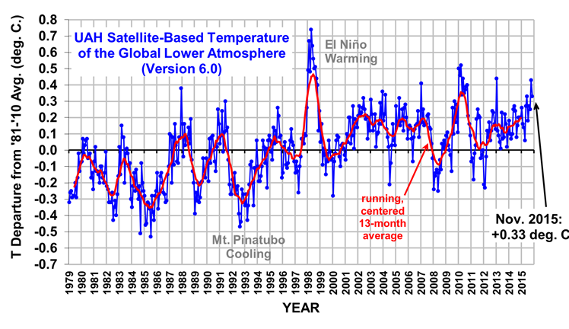
It's rather obvious here that the warmest year was 1998, and indeed the peak was in early 1998. That's almost 18 years ago! What does it even mean to say that "the Earth is warming" when the best data show that the warmest time was 18 years ago? The trend since 1998 is down, not up. The trend since 1997 is completely flat.
"If you look at satellite data for the last 18 years, there's been zero recorded warming . . . . The satellite says it ain't happening . . . I'm saying that data and facts don't support it."
For that heresy Cruz drew a response from billionaire and former Mayor Mike Bloomberg in a CNN interview on November 25. Bloomberg referred to "right wing crazies" who reject mainstream climate science, and particularly said he was talking about Cruz:
You've got a guy like Ted Cruz . . . and he says some of the stupidest things I've ever heard.
Yes, in the field of climate "science," pointing out that the data refute the hypothesis is now "crazy" and "the stupidest thing I've ever heard." Who again is the unscientific one here?
But, you ask, what about those seemingly monthly press releases from NOAA and NASA, based on ground thermometers rather than satellites, that keep reporting that each successive month and year are "the hottest ever"? Readers here know that this is what I have referred to as "The Greatest Scientific Fraud Of All Time." Read some previous articles in this series here. As reported in those articles, numerous non-government-funded independent researchers have gone to check the raw archived temperature data from many stations against the current NOAA and NASA data bases that generate the reports of "hottest ever," and uniformly they find the same thing: early year data altered downward, and recent year data altered upward, in order to create a warming trend where otherwise none exists. See, for example, Tony Heller's Real Science here, Paul Homewood's Not a Lot of People Know That, Joe D'Aleo's Icecap.
Now for the latest on that. In Germany, a retired geologist and data computation expert named Friederich Karl Ewert recently decided to follow the lead of Heller, Homewood, D'Aleo, et al., and try his hand at comparing archived raw temperature data from many weather stations to currently-reported temperatures from NASA. Here is the result, reported on November 20 at No Tricks Zone:
From the publicly available data, Ewert made an unbelievable discovery: Between the years 2010 and 2012 the data measured since 1881 were altered so that they showed a significant warming, especially after 1950. […] A comparison of the data from 2010 with the data of 2012 shows that NASA-GISS had altered its own datasets so that especially after WWII a clear warming appears – although it never existed.
Surprise! It's "unbelievable." Actually not, if you've been following this issue at all. According to my Google search here, the Ewert study has been reported at Breitbart, CNS, No Tricks Zone, Not a Lot of People Know That, Weasel Zippers, Hockey Schtick, Free Republic, The Federalist Papers, and many others -- all of them conservative-oriented sources. But somehow no mention at literally any so-called "mainstream" source: New York Times, Washington Post, NBC, ABC, CBS, CNN, Bloomberg, etc., etc., etc. If anybody can find a mention in any mainstream source, I'll be interested to know. Have the facts really become this partisan?
So 40,000 people, all on government payroll, meet in Paris to seek to put over on the world's people a spending/control program of multi-trillions of dollars, all based on so-called "facts" that all are required to believe but are contradicted by the best available data. Our primary media sources systematically suppress the data. Yes, the world truly has gone mad.

The Greatest Scientific Fraud Of All Time -- Part X
It's been a while (since December) since I last wrote a post in this series. The reason is that nothing ever seems to change. On the one hand, the proponents of the official government warming line, most notably the bureaucrats at NASA/GISS, continue to make regular announcements that global temperatures have set some kind of new record. On the other hand, independent researchers continue to point out that government data, available online, contradict the contention of record-setting heat, at least if the data prior to recent "adjustments" is used; the entire apparent increase in temperatures existing in government so-called "final" (post-adjustment) data lies in the unexplained adjustments. Demands for detailed explanation of the adjustments continue to be made, and the bureaucrats simply ignore those demands. And of course the "mainstream" media go merrily on reporting whatever NASA/GISS says, without ever asking so much as a semi-intelligent question about such things as the adjustments or the discrepancies between the satellite and "surface" temperature records Really, it's bizarre.
Anyway, we're just going through another round of same, so I might as well inform you about it. On Tuesday, NASA/GISS made one of the regular announcements. It was reported upon by all of the usual "mainstream" suspects, with the usual complete lack of skepticism or curiosity: the New York Times here, livescience.com here, the Guardian here, USA Today here, Scientific American here ("First Half of 2016 Blows Away Temperature Records"), etc., etc., etc. Try to find so much as a hint in any of them that they are even aware of the massive adjustments or that they think their readers are entitled to an explanation. It's just parroting of whatever NASA's Gavin Schmidt says. From the New York Times:
Gavin Schmidt, the director of NASA’s Goddard Institute of Space Studies, said that while the first six months of 2015 made it the hottest half-year ever recorded, “2016 really has blown that out of the water.” He said calculations showed there was a 99 percent probability that the full year would be hotter than 2015.
But, you ask, why the strange timing? Why make an announcement in mid-July that 2016 has "a 99 percent probability" of being the warmest year, instead of waiting until later in the year (or after the end of the year) when you actually know? Of course, to people who follow what's going on, it's obvious: The most recent two months (May and June) have seen the largest two-month drop ever in satellite-measured tropical temperatures, and the second-largest two-month drop in satellite-measured global temperatures. Go to Roy Spencer's web site for more detail on the latest satellite temperatures. Spencer describes what is currently going on as "rapid cooling" following the break-up of the 2015-16 El Nino. In other words, if Schmidt had waited another month or two for his announcement, he would have a big risk of missing his opportunity to influence the election with his apocalyptic statements.
Meanwhile, on July 9 the estimable Tony Heller gave an excellent presentation on the subject of all of NASA's alleged warming being a result of the unexplained adjustments. You can watch him giving the presentation here; a copy of his slides and charts is here. It's just data, data and more data. He has actual temperature records from the 1930s and 1940s showing those years to be much warmer than today. And he has pdf copies of newspaper articles from the time to back himself up. And he has NASA charts and Hansen (then-head of NASA/GISS) articles from the 80s and 90s showing no warming to that time. And then he has the current NASA "final" (adjusted) data. In the "final" data, the 1930s and 40s temperature records have been made to disappear. Would you think that somebody from some media outlet -- New York Times, USA Today, Scientific American, et al. -- would at least ask Schmidt a question about this? It's beyond comprehension.

The Greatest Scientific Fraud Of All Time -- Part XI
If you have been following my series on The Greatest Scientific Fraud Of All Time, you know that I am referring to the world temperature data tampering fraud, by which the guardians of world surface thermometer records (in the U.S., NASA and NOAA) "adjust" old temperatures down and new temperatures up in order to provide fake support for the official "global warming" narrative.
My last post in this series (Part X) was back in July. Meanwhile, 2016 has proved to be a rather suspenseful year for those following this issue. The start of the year was a time of a massive El Nino. El Ninos (warm surface conditions in the equatorial Pacific Ocean) are known to be highly correlated with somewhat lagged spikes in atmospheric near-surface temperatures, as the oceans give up some heat into the air. Unsurprisingly, the years of the strongest El Ninos have also been the years of highest recorded lower tropospheric temperatures in the now 38-year (back to 1979) satellite temperature record -- most notably the year 1998, until now the record-holder for the warmest year in the satellite record. But with a comparably massive El Nino extending well into 2016, would 2016 now end the 18-year global warming "pause," break the prior record, and give new support to the cause of climate alarmism?
Throughout the year, the temperature "adjusters" at NASA have been working to prepare the ground for the big end-of-year announcement that temperatures have finally broken the old record. In the first several months, as the effects of the El Nino lingered, they put out breathless monthly press releases announcing that month to be the "hottest [March, April, May, whatever] since records began," or something like that. Here is NASA's release from July 20. Excerpt:
Each of the first six months of 2016 set a record as the warmest respective month globally in the modern temperature record, which dates to 1880, according to scientists at NASA's Goddard Institute for Space Studies (GISS) in New York. The six-month period from January to June was also the planet's warmest half-year on record, with an average temperature 1.3 degrees Celsius (2.4 degrees Fahrenheit) warmer than the late nineteenth century.
But then a few months after the break-up of the El Nino, the atmospheric temperatures started their inevitable sharp decline. By October, NASA had suspended the breathless press releases; but its director of GISS, Gavin Schmidt, put out a tweet in that month that made it into the Guardian:
Dr Gavin Schmidt, director of Nasa’s Goddard Institute for Space Studies, tweeted: "With data now available through September, 2016 annual record (~1.25ºC above late 19th C) seems locked in." Last month was only just over the previous record, coming in at a razor-thin 0.004C above the previous high for the time of year, reached in September 2014. That tiny margin may be revised in future, as monthly temperature data can be nudged up or down retrospectively as later reports come in. For instance, June 2016 was initially reported as the warmest on record but was subsequently revised downward slightly to the third warmest.
June 2016 was revised down and no longer a record? Funny, I missed any press reports on that one.
Anyway, yesterday Roy Spencer of UAH (provider of satellite-based data) put out the results for December and full-year 2016. The UAH global lower troposphere anomaly declined a full .21 deg C in December, going from + 0.45 deg C to + 0.24 deg C. And with that sharp drop, 2016 ended in what Spencer calls a "statistical tie" with 1998:
The resulting 2016 annual average global temperature anomaly is +0.50 deg. C, which is (a statistically insignificant) 0.02 deg. C warmer than 1998 at +0.48 deg. C. We estimate that 2016 would have had to be 0.10 C warmer than 1998 to be significantly different at the 95% confidence level. Both 2016 and 1998 were strong El Nino years.
So, too bad for those hoping for a big new full-year record in the satellite data. The "pause" resumes. But still no word from NASA as to their year-end figures. Not to worry. NASA has a different data source from the satellites, namely the network of surface weather stations whose data can be "adjusted" and "homogenized" to get essentially whatever answer NASA wants in support of its favored political narrative. The excellent Tony Heller, in a post titled "Why Temperature Fraud Matters," is already on top of the stream of NASA data, and provides this graph as of yesterday to compare recent NASA ("adjusted" surface station) data to UAH (satellite) data:
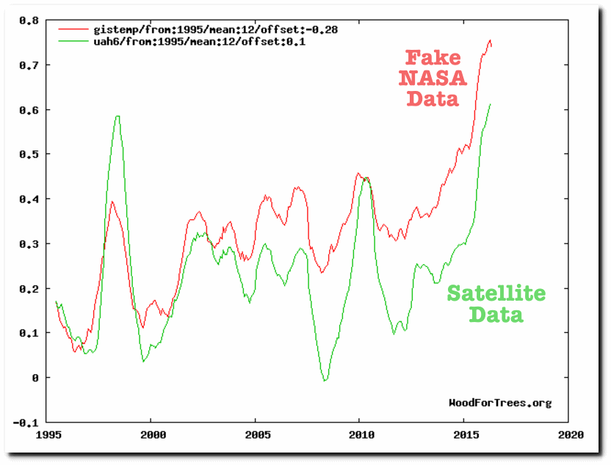
Yes, NASA has baked in a good 0.2 deg C or so of "adjustments" just since 1995 to give it a comfortable margin to claim a "record" for 2016. Expect that breathless announcement from NASA within the next couple of weeks. (Prior experience indicates that NASA press releases come out around the 18th to 20th of the month.)
If you want to make a prediction of the future about as safe as predicting the time of tomorrow's sunrise, you can predict that every mainstream news source in the country will parrot the upcoming NASA press release without mentioning that the new supposed "record" is not supported by the far-more-accurate satellite data. Nor will any mainstream news source ask the obvious question of how it is that global warming is supposed to be caused by CO2 emissions, yet temperature records always and only seem to be associated with El Ninos, and there is no plausible mechanism to explain how CO2 emissions into the air have any causative effect on the El Nino ocean current phenomenon. Hey, that would ruin our good sin-and-redemption story! We can't have that!
In related news, famed climate scientist Judith Curry, long head of the department at Georgia Tech, has announced her early retirement and an intended move into the private sector. Here is her post at her own blog. She began her transition to skepticism all the way back in 2005, and the years since have only seen a growing disgust:
A deciding factor was that I no longer know what to say to students and postdocs regarding how to navigate the CRAZINESS in the field of climate science. Research and other professional activities are professionally rewarded only if they are channeled in certain directions approved by a politicized academic establishment — funding, ease of getting your papers published, getting hired in prestigious positions, appointments to prestigious committees and boards, professional recognition, etc. How young scientists are to navigate all this is beyond me, and it often becomes a battle of scientific integrity versus career suicide.
Well, that's the legacy of the Obama-era bureaucracy and its lackeys in academia. The funding situation may be about to change by 180 degrees. We'll see.

The Greatest Scientific Fraud Of All Time -- Part XII
Perhaps the most gratifying part of writing this series comes from the comments. Not only are the large majority of the comments favorable, but they make clear that there is an enormous reservoir of people out there who have figured out that they are being systematically lied to by the government and the mainstream media on the subject of claimed world temperature records. And indeed, as soon as you catch onto some of the real data, you quickly recognize that what comes out of the government and mainstream sources like the New York Times, Washington Post, Bloomberg, and the major television networks on this subject is insulting to your intelligence and is transparent propaganda.
Expect that breathless announcement from NASA [that 2016 temperatures have set a new record] within the next couple of weeks. . . . If you want to make a prediction of the future about as safe as predicting the time of tomorrow's sunrise, you can predict that every mainstream news source in the country will parrot the upcoming NASA press release without mentioning that the new supposed "record" is not supported by the far-more-accurate satellite data.
The NOAA/NASA press release of 2016 temperatures came out yesterday. Let's see how I did at predicting the future!
I'll start with just a little background to help with understanding this issue. First, as reported on January 4, the UAH satellite data had shown 2016 to be 0.02 deg C warmer than the previous record, which, although a new record, is within the measurement accuracy of the instruments, and therefore was described by Roy Spencer of UAH as a "statistical tie" with the previous record warm year (1998 in the satellite record). Next, recall from the many prior posts in this series that the NASA and NOAA data come from a different source, namely a network of ground-based thermometers -- and that the data from the thermometers have been "adjusted" over the years, somehow always to lower older temperatures and raise recent ones. What is the total of the "adjustments"? The excellent Tony Heller of the Deplorable Climate Science Blog has two charts in a brand new post from January 13. He calls the actual temperatures measured at the time "measured," and the adjusted version appearing in the latest government statistics "reported." Here are the charts:
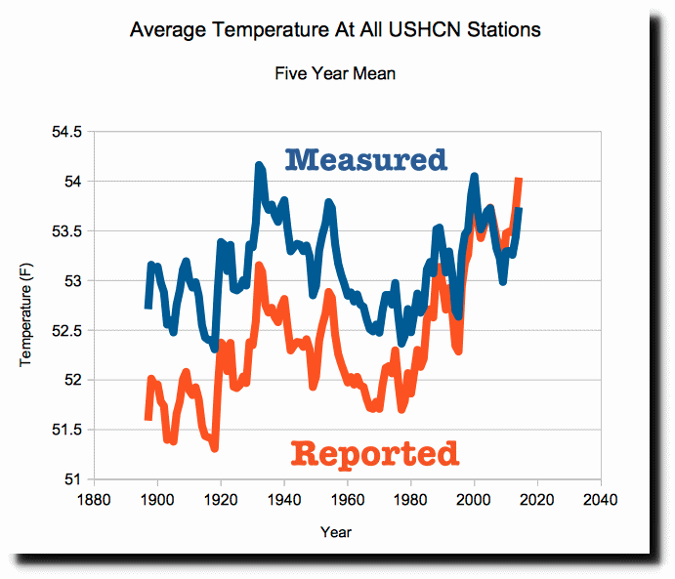
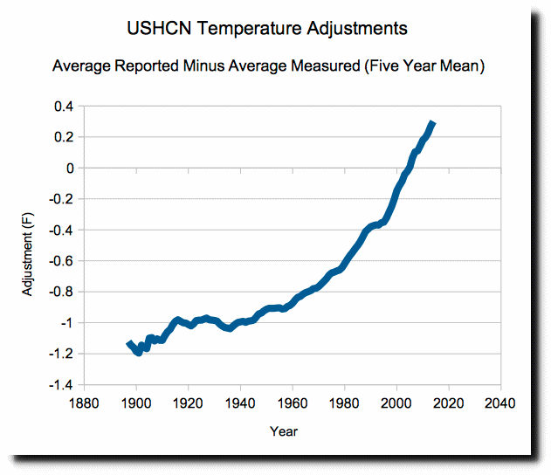
As you can see, the total amount that the government has "adjusted" the 1890 - 2016 temperature data is about 1.5 deg F, with all adjustments prior to 2000 being to lower the temperatures, and the adjustments getting larger the farther back you go, while all adjustment post-2000 have been to raise temperatures, with the adjustments getting larger the closer you get to the present.
With that background, let us consider the NOAA/NASA announcement of 2016 temperatures came out today. Drumroll!!!!!!
During 2016, the average temperature across global land and ocean surfaces was 1.69°F (0.94°C) above the 20th century average. This was the highest among all 137 years in the 1880–2016 record, surpassing the previous record set last year by 0.07°F (0.04°C). The first eight months of the year had record high temperatures for their respective months. Since the start of the 21st century, the annual global temperature record has been broken five times (2005, 2010, 2014, 2015, and 2016). The record warmth in 2016 was broadly spread around the world.
That's right: In a record where they have made 1.5 deg F of unexplained "adjustments" all to increase the reported warming, they claim a record by 0.07 deg F! Whoopee!
But, guys, what is the measurement accuracy of your system? I mean, for starters, you are purporting to measure some kind of "average" world temperatures with a network of thermometers that are by no means evenly spaced to measure all areas equally. You have a heavy concentration of stations in the U.S. and Europe, and almost none in places like the arctic, Antarctic, oceans, Africa, Amazonia and Siberia. On top of that, you have made adjustments totaling about 1.5 deg F. Really, if you can make adjustments that large, how can you say that your measurement accuracy is any better than the whole 1.5 deg F -- and it may be even worse than that. The fact is that they have no basis for saying that 2016 was actually warmer than 2015, or for that matter, than 1998.
So let's look at that NOAA press release from yesterday and see if we can find any discussion of measurement accuracy. You guessed it -- it's not there. Nothing. Also, of course, no mention of the adjustments, or of the direction of the adjustments. Do you like the breathless claim that "average temperature . . . was 1.69 deg F . . . above the 20th century average" without even mentioning that the so-called "20th century average" was adjusted downward by them by almost that much? Hey, government: We are not idiots!
Now to the mainstream news sources. Call them the official parrots for government propaganda. New York Times, "Earth Sets a Temperature Record for the Third Straight Year", by lead climate propagandist Justin Gillis:
Marking another milestone for a changing planet, scientists reported on Wednesday that the Earth reached its highest temperature on record in 2016, trouncing a record set only a year earlier, which beat one set in 2014. It is the first time in the modern era of global warming data that temperatures have blown past the previous record three years in a row.
"Trouncing" and "blowing past" previous records? Really? Can you even mention the subjects of the quantitative amount by which the prior record was allegedly broken, measurement accuracy, adjustments to the data, or the satellite record? Of course not. This is Pravda. Insulting. The article is accompanied by a big graphic (that appears prominently on the front page of today's print edition) showing temperatures since about 1880 in the iconic hockey stick presentation -- without ever mentioning that the data have been adjusted in amounts constituting the majority of the entire vertical scale of the chart. Instapundit comments: Increase is one-hundredth of a degree. Margin of error is a tenth of a degree. So it’s all bullshit. My further comment: No way is the margin of error as little as a tenth of a degree. At best, it's a full degree.
It’s not a hoax. There’s no conspiracy. And no exaggeration. What follows are 137 years of diligently kept scientific records that show how humans are transforming Earth’s climate. . . . To say that last year was hot is an understatement. It was 1.69 degrees Fahrenheit (0.94 Celsius) warmer than the 20th century average, according to National Oceanic and Atmospheric Administration figures released on Wednesday. That may not sound like much, but on a planetary scale it’s a profound shift . . . .
I love that "137 years of diligently kept scientific records" without the slightest mention that almost all of the warming is in the unexplained government "adjustments." And of course, absolutely nothing about the quantitative size of the record, or margins of error.
In a powerful testament to the warming of the planet, two leading U.S. science agencies Wednesday jointly declared 2016 the hottest year on record, surpassing the previous record set just last year — which itself had topped a record set in 2014. Average surface temperatures in 2016, according to the National Oceanic and Atmospheric Administration, were 0.07 degrees Fahrenheit warmer than 2015. . . .
I wonder if any reader of the Washington Post is a sufficiently critical thinker to recognize that a record supposedly set by a margin of 0.07 deg F is not a "powerful testament" to anything.
Last year was the hottest year ever recorded, marking the third year in a row that average global temperatures hit record-setting levels, NASA and NOAA said Wednesday.
I could go on with this all day, but you get the picture. Of course my prediction was absolutely right; but then, I could also predict the time of tomorrow's sunrise to within a tiny fraction of a second. To revert to my opening, I am extremely gratified that so many people have seen through the ceaseless drumbeat of government and media propaganda.

The Greatest Scientific Fraud Of All Time -- Part XIII
The "Greatest Scientific Fraud Of All Time" is the world temperature data tampering fraud, by which the politicized keepers of world temperature data, most notably at U.S. agencies NOAA and NASA, alter past temperature records to support a narrative of ongoing record-setting global warming. Past articles in this series (Parts I through XII) can be found at this link.
I have always thought that the fraud would finally crack when a whistleblower or two would step forward. But with the government passing out all the money, and strict conformance to orthodoxy required to keep your job and career in the field of climate science, that has not occurred. Until now. Two weeks ago we got President Trump, and a pledge to "drain the swamp." Over this weekend, the first whistleblower on the temperature data tampering fraud has stepped forward. He is Dr. John Bates, recently (late 2016) retired from the job of "Senior Scientist" at NOAA's temperature data operation in Asheville, NC, which is known (after a recent name change) as NCEI (National Centers for Environmental Information). The particular subject on which Bates has blown the whistle is the data underlying a June 2015 paper that appeared in Science magazine, authored by Thomas Karl and others, titled "Possible artifacts of data biases in the recent global surface warming hiatus." Karl, until his own recent retirement, was the Director of NCEI.
First, some background so that you will understand the importance of this development. The year 2015 was targeted by the Obama administration to be the culmination of its climate agenda. A big summit was scheduled in Paris for December, to be attended by President Obama himself, and at which he badly wanted to sign the U.S. on to a global treaty calling for restrictions on "greenhouse gas" emissions. But the administration had a problem, which was that according to the best (satellite) data, as of mid-2015 world temperatures had been in a "pause," or "hiatus," showing no trend either up or down, for some 17 years since 1998. The "pause" had become the number one talking point of so-called climate "skeptics" and others seeking to de-rail the upcoming Paris meetings.
Then, with exquisite timing, the Karl, et al., paper appeared in Science on June 4. It claimed to do a re-analysis of temperature records and trends, based in large part on new or updated data sets, to reach a conclusion that there had been no "pause" or "hiatus" at all; rather, the paper concluded, based on its updated data, that the so-called "hiatus" was an "artifact of data biases." Needless to say, the Karl paper came out with a massive government-orchestrated press barrage, and was picked up and parroted in all the usual "mainstream" media sources. (E.g., New York Times, June 4, 2015, "Global Warming 'Hiatus' Challenged by NOAA Research"). Skeptics were equally quick to debunk the Karl paper. (See, for example, Anthony Watts and Bob Tisdale at Watts Up With That, June 4, 2015, "NOAA/NCDC’s new ‘pause-buster’ paper: a laughable attempt to create warming by adjusting past data"; and don't forget Manhattan Contrarian, June 7, 2015, "The Greatest Scientific Fraud Of All Time -- Part V"). According to a later post by Anthony Watts here, he told Karl in an email in June that his "highly questionable" paper was going to be the "Waterloo" for its authors.
The next step came in October 2015, when the House Committee on Science, Space and Technology, chaired by Congressman Lamar Smith of Texas, issued a subpoena to NOAA for the research documents underlying the Karl, et al. paper. And then, in a highly unusual move, NOAA flatly refused to comply with the Congressional subpoena. (Inside Climate News, October 28, 2015, "NOAA Stiff-Arms House Science Committee Subpoena Questioning 'Hiatus' Study"). And the Obama Justice Department refused to enforce the subpoena on behalf of Congress. As far as I can ascertain, Smith never got the information he was seeking. Something tells me some people at NOAA may shortly be wishing that they had complied.
Which brings us up to the recent events. According to this post at Judith Curry's Climate, etc., upon his retirement from NOAA late last year, Dr. Bates initially submitted an op-ed to the Washington Post in December 2016 setting forth his revelations. Needless to say, the Post declined to publish it. After discussions with Ms. Curry, they decided to publish a longer version of the revelations at her site, and it appeared there on Saturday February 4. Bates also provided his revelations to David Rose of the UK's Daily Mail, and a long article appeared there today. The headline for Rose's article is "Exposed: How world leaders were duped into investing billions over manipulated global warming data."
Rather than try to paraphrase, I'll include some fairly long quotes from Rose's article.
A high-level whistleblower has told this newspaper that America’s National Oceanic and Atmospheric Administration (NOAA) breached its own rules on scientific integrity when it published the sensational but flawed report, aimed at making the maximum possible impact on world leaders including Barack Obama and David Cameron at the UN climate conference in Paris in 2015.
The report claimed that the ‘pause’ or ‘slowdown’ in global warming in the period since 1998 – revealed by UN scientists in 2013 – never existed, and that world temperatures had been rising faster than scientists expected. Launched by NOAA with a public relations fanfare, it was splashed across the world’s media, and cited repeatedly by politicians and policy makers.
But the whistleblower, Dr John Bates, a top NOAA scientist with an impeccable reputation, has shown The Mail on Sunday irrefutable evidence that the paper was based on misleading, ‘unverified’ data. . . .
His vehement objections to the publication of the faulty data were overridden by his NOAA superiors in what he describes as a ‘blatant attempt to intensify the impact’ of what became known as the Pausebuster paper. . . .
In an exclusive interview, Dr Bates accused the lead author of the paper, Thomas Karl, who was until last year director of the NOAA section that produces climate data – the National Centers for Environmental Information (NCEI) – of ‘insisting on decisions and scientific choices that maximised warming and minimised documentation… in an effort to discredit the notion of a global warming pause, rushed so that he could time publication to influence national and international deliberations on climate policy’.
There's lots more in the Mail article, and in Dr. Bates's post at Climate, etc. Among the most important points are (1) the data underlying the Karl, et al., paper have never been properly archived, in violation of policy of both NOAA and Science, with the result that the paper cannot be replicated; and (2) the computer on which the secret Karl, et al., data resided has crashed and is unusable. In other words, it's more or less the usual for the "science" coming out of NOAA and purporting to support the global warming narrative.
This story has just broken this weekend, and is already all over the skeptic sites like Watts Up With That, Icecap, Powerline, Climate Depot, Tallbloke, Breitbart, Zero Hedge and others. But my searches don't turn up anything on any "mainstream" source, like the New York Times, Washington Post, CNN, ABC, NBC, CBS, Bloomberg, or for that matter any major science site like Scientific American, Science or Nature. Are they going to just try to ignore this and see if they can get away with it?
It is highly likely that criminal conduct occurred here, both in the intentional manipulation of data and in the obstruction of refusing to comply with a valid subpoena. It seems like the paper's authors were counting on the Justice Department remaining in friendly hands until the expiration of the statute of limitations. Unfortunately for them, that has not occurred.

The Greatest Scientific Fraud Of All Time -- Part XIV
The Daily Caller reported over the weekend that Congress is about to pass a bill zeroing out the budget of NASA's "Earth Sciences" division for global warming research:
Republicans plan to end the more than $2 billion NASA spends on its Earth Science Mission Directorate. “By rebalancing, I’d like for more funds to go into space exploration; we’re not going to zero out earth sciences,” Texas Republican Rep. Lamar Smith, who chairs the House Committee on Science, Space and Technology, told E&E News.
Well, this couldn't come soon enough. These NASA bureaucrats are the people who, under leader Gavin Schmidt, engineer just enough "adjustments" to world temperature records each year to make it possible to claim that this year has just set a new "record" for high temperatures. Always, the "adjustments" seem to make the past cooler and the present warmer. For lots of detail on this subject, see parts I through XIII of this series, available at this link.
I come back to this topic today because a guy named John Mauer has a post today at Watts Up With That about NASA adjustments to temperatures at a weather station near and dear to myself, namely the one at Falls Village (Town of Canaan), Connecticut. I own a house in the adjacent town of Salisbury, about 3 miles from this weather station; and I pass it regularly. Mauer has collected the details of recent adjustments made by NASA to the temperatures at Falls Village, as well as NASA's stated rationale for the adjustments. It couldn't be more preposterous.
Here's Mauer's picture of the aerial view of the siting of the weather station. It's next to the Falls Village power station, and right down by the Housatonic River, which is visible in the view. The river forms the border between Canaan and Salisbury, so the small piece of land visible in the picture on the other side of the Housatonic is actually in the Town of Salisbury.
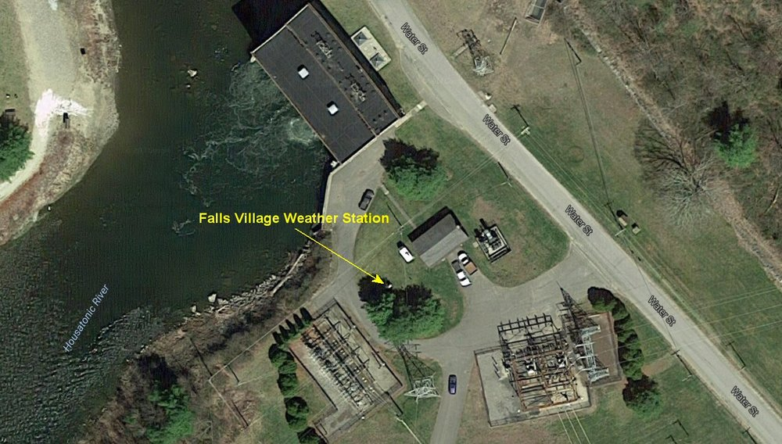
The temperature record for this station goes back 101 years, to 1916. You might think that the power station might affect the record some, but it was actually built in 1914. Also, it's not very big (11 MW), and is a hydro plant associated with the waterfall on the river that's just out of view.
Mauer points out that NASA chose to make some substantial adjustments to the historical temperature record at this station in 2015, conveniently timed to be shortly before the big Paris climate conference at the end of that year. You won't be surprised that the adjustments are completely typical for NASA adjustments at all weather stations: the past has gotten substantially cooler when compared to the raw data, while the recent years to the present have either stayed the same or gotten a little warmer. NASA itself actually provides a graph demonstrating the changes, and Mauer has copied that graph in his post:
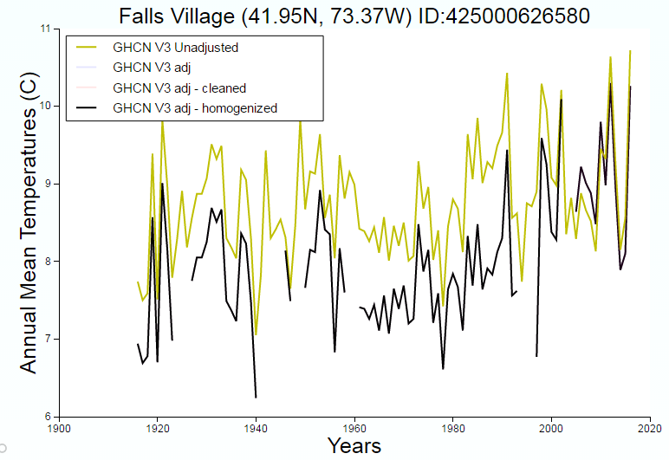
Mauer has then backed the adjustments out of this graph and compiled them into this new graph of his own:
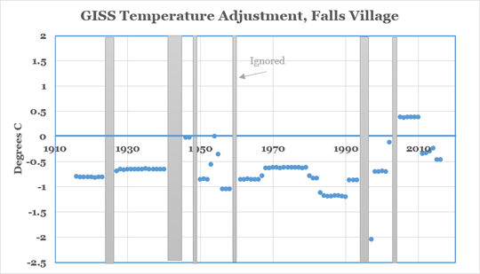
Suddenly what might have seemed like some sophisticated scientific work when you looked at NASA's graph is revealed as not so sophisticated at all. From 1916 to 1924, they have just lowered all annual average temperatures by a flat 0.8 deg C. Then, after a gap of a few years in the adjusted series (unexplained), they lower all temperatures from 1927 to 1939 by a flat 0.6 deg C. In the 70s they seem to have gone for a negative 0.6 deg C adjustment, while for the 80s they went for negative 1.2 deg C. But suddenly in the 2000s, the adjustment became + 0.4 deg C.
OK guys, can you kindly explain. This time I will quote from the NASA website:
GHCN-adj-homogenized is the adjusted, cleaned data with the GISTEMP removal of an urban-only trend.
"Removal of an urban-only trend"? Really? In Falls Village, Connecticut? I can't even start to figure out what this means.
First of all, Falls Village is about the opposite of "urban." It is approximately 100 miles from New York City. The latest Census estimate of the population of the Town of Canaan is 1195 people in 33 square miles. (Adjacent Town of Salisbury has 3665 people in 60 square miles.) In my only quibble with Mauer, he says that the Town of Canaan is "mostly farmland." Actually not -- it is about 80% forest, and of the unforested part, much is lawns or fields that are not farmed. There are very few farms left. This part of Connecticut has been reverting to forest for a good century and a half. See my famous Defunct Agriculture Tour of the area here. The population of the Town of Canaan actually peaked in 1850 at 2627, and hasn't remotely recovered.
But even if the Town of Canaan were an "urban" area, or even semi- or partially-urban, how could it make sense to adjust temperatures from 50 and 100 years ago down by half a degree or more? If Canaan had become an urban "heat island," wouldn't that mean that you should adjust recenttemperatures down (to account for distortions coming from buildings or pavement or whatever), while leaving the past the same? Well, that's not the way it works at NASA. I think that the game plan is to bury this stuff in lots of details and hope that nobody has the time or inclination to get into the weeds and ask any difficult questions.
Again, they can't fire these guys fast enough. But I'll still believe it when I see it. Meanwhile, they could use about 100 new people to go in and audit what's been going on for the last 20 years.

The Greatest Scientific Fraud Of All Time -- Part XV
It's been several months since I've added a post to this series, since this one back on February 22. There's good reason for that. With the breakup of last year's big El Niño, global temperatures declined significantly. The latest global temperature anomaly from the UAH satellite temperature series is +0.21 deg C for June 2017 -- down a remarkable 0.65 deg C from the February 2016 global anomaly of +0.86 deg C. The Northern Hemisphere anomaly dropped even more, by 0.86 deg C, from +1.19 deg C to only +0.32 deg C. Those declines represent well more than half of the entire warming that had been present in the satellite record at the peak of the El Niño, and bring recent temperatures below those recorded during many months in the 1980s and 90s. It's no wonder that the breathless press releases from NASA and NOAA trumpeting "hottest [April, May, June, etc.] ever!" have at least temporarily ceased.
But the lack of "record warming" announcements coming out of the government has not stopped independent researchers from further examining the surface temperature records from NASA and NOAA (and also from a British group called Hadley CRU that gets its starting data from the same source) to try to quantify and understand the "adjustments" that continue to be made. Readers of my series know that NASA, NOAA and Hadley CRU report global temperatures derived from a different source from the satellites, namely a network of land- and ocean-based surface weather stations known as the Global Historical Climate Network, or GHCN. These so-called "surface temperatures" are inherently in need of some ongoing adjustments, to account for things like station moves and nearby urbanization. But somehow the adjustment process has gotten into the hands of some committed global warming zealots, and next thing you know each round of adjustments seems progressively to make the past cooler and the present warmer, thus always enhancing the apparent warming. Oh, plus the adjusters refuse to release details of the bases and methodology for the adjustments. After a few decades of this, reasonable people come to have serious and well-justified doubts about whether the reported warming trends can be trusted.
The latest effort at analyzing the adjustments comes from a team of independent researchers led by James Wallace, and including Joseph D'Aleo and Craig Idso. Their new Research Report can be found at this link, titled "On the Validity of NOAA, NASA and Hadley CRU Global Average Surface Temperature [GAST] Data & The Validity of EPA’s CO2 Endangerment Finding." The new Research Report has seven highly qualified peer reviewers identified in the paper itself. From the Abstract:
In this research report, the most important surface data adjustment issues are identified and past changes in the previously reported historical data are quantified. It was found that each new version of GAST has nearly always exhibited a steeper warming linear trend over its entire history. And, it was nearly always accomplished by systematically removing the previously existing cyclical temperature pattern. This was true for all three entities providing GAST data measurement, NOAA, NASA and Hadley CRU.
As others have previously noticed, the periodic revisions to GAST data from all three entities have brought with them a systematic cooling of the past and warming of the recent and the present, to a degree that hugely strains credulity. But the new Wallace, et al., paper takes another step, and examines the equally systematic removal from the surface temperature record of a cyclical pattern widely reflected in raw temperature data from multiple regions. As the paper notes, if you look at much raw (unadjusted) data, a cyclical pattern is immediately obvious: temperatures gradually increase from the beginning of records in the late nineteenth century through about 1940; then temperatures decrease through about the 1970s; then the increase resumes through about 2000; and finally temperatures level off through the present. This cycle results in a temperature peak around 1940, sometimes referred to as the "blip." The "blip" has long been recognized to be a problem for the hypothesis that human greenhouse gas emissions are the principal control knob for global temperatures, because human emissions had barely begun before 1940 -- when temperatures were increasing -- and then human emissions began to increase sharply from the 1950s to the 1970s -- when temperatures were declining. Doesn't that significantly undermine the hypothesis? The successive rounds of adjustments to the surface temperature records have systematically removed this "blip," making for a temperature record seemingly supporting the hypothesis. Could this possibly be honest? From the Wallace, et al., paper:
As has been clearly shown in Section IV above, the consequences of the changes made to previously reported historical versions of GAST data have been to virtually eliminate the previously existing cyclical nature of their previously reported trend cycle patterns. The notion that there was a 1930 and 40s warm period followed by a mid-1970 cool period now gets lost in the noise so to speak.
As just one example from the paper, a comparison of the GAST data from NASA from May 2017 versus May 2008 shows that, in between the issuance of those two versions of the data, nearly all annual mean temperatures from approximately 1920 to 1940 have been reduced by between 0.05 deg C and 0.20 deg C, while nearly all annual mean temperatures from approximately 1980 to 2000 have been increased by between 0.05 deg C and 0.20 deg C. The obvious effects have been substantially to remove the 1940s "blip" and to strongly enhance the warming trend. Other data revisions at different points in time have made additional changes to the same effect. The basis and methodology for these adjustments have never been explained.
Have these adjustments been part of an intentional program to alter data to fit the desired hypothesis -- in other words, classic scientific fraud? The 2009 Climategate emails give additional evidence. For example, one of the best known of those emails is the September 27, 2009 message from Tom Wigley of NCAR to Phil Jones, head of Hadley CRU. In that email, Wigley proposes an intentional effort to reduce the ocean part of the surface record by 0.15 deg C, not to make the record a better representation of reality, but rather to make the evidence fit the narrative. Excerpts:
So, if we could reduce the [1940s] ocean blip by, say, 0.15 degC, then this would be significant for the global mean -- but we'd still have to explain the land blip. I've chosen 0.15 here deliberately. This still leaves an ocean blip, and i think one needs to have some form of ocean blip to explain the land blip (via either some common forcing, or ocean forcing land, or vice versa, or all of these). . . . My 0.15 adjustment leaves things consistent with this, so you can see where I am coming from. Removing ENSO does not affect this. It would be good to remove at least part of the 1940s blip, but we are still left with "why the blip".
From the conclusion of the Wallace, et al., paper:
While the notion that some “adjustments” to historical data might need to be made is not challenged, logically it would be expected that such historical temperature data adjustments would sometimes raise these temperatures, and sometimes lower them. This situation would mean that the impact of such adjustments on the temperature trend line slope is uncertain. However, each new version of GAST has nearly always exhibited a steeper warming linear trend over its entire history. That was accomplished by systematically removing the previously existing cyclical temperature pattern. This was true for all three entities providing GAST data measurement, NOAA, NASA and Hadley CRU. . . .
The conclusive findings of this research are that the three GAST data sets are not a valid representation of reality. In fact, the magnitude of their historical data adjustments, that removed their cyclical temperature patterns, are totally inconsistent with published and credible U.S. and other temperature data. Thus, it is impossible to conclude from the three published GAST data sets that recent years have been the warmest ever – despite current claims of record setting warming.
The adjustments to the GAST record have been part of a coordinated effort to influence public policy by supporting restrictions on greenhouse gas emissions. In the United States, the EPA's finding that CO2 constitutes a "danger" to human health and welfare rests on what EPA calls its three "lines of evidence," one of which is the supposedly "record warming" as shown in the GAST data. Oh, it now seems that the "record warming" is not present in the raw data, but is nothing more than an artifact of adjustments made by government bureaucrats. The final conclusion of the Wallace, et al., paper:
[S]ince GAST data set validity is a necessary condition for EPA’s GHG/CO2 Endangerment Finding, it too is invalidated by these research findings.
On July 6 my co-counsel and I submitted a Supplemental Petition to EPA, citing this new paper, seeking to have EPA reopen and reconsider the Endangerment Finding. We have called upon EPA to hold hearings on the record and under oath, at which hearings the people who have made the "adjustments" to create supposedly record warming should be called upon to set forth their detailed methods. It is high time that the people who have made these adjustments justify their handiwork to the American people.
UPDATE, July 9, 2017: It occurs to me that readers may be interested in this tidbit of information: That September 27, 2009 email from Wigley to Jones has a cc -- to a guy named Ben Santer. Do you recognize the name? He is another "scientist" on the government/taxpayer dime, and another serious global warming zealot, who works at the Livermore Lab in California. You may have seen his op ed in the Washington Post on June 21, 2017, title "Attention Scott Pruitt: Red teams and blue teams are no way to conduct climate science." Excerpt:
[C]alls for special teams of investigators are not about honest scientific debate. They are dangerous attempts to elevate the status of minority opinions, and to undercut the legitimacy, objectivity and transparency of existing climate science.
What are you afraid of, Ben? Time to get this guy under oath!
And here's yet another bit of similar news. You may recall that several years ago (real) Canadian climate scientist Tim Ball wrote of (fake) Penn State climate scientist Michael "Hockey Stick" Mann that "he belongs in the state pen, not Penn. State." Mann sued Ball for libel in a court in Vancouver, Canada. Ball demanded to get in discovery the underlying data and computer code that support Mann's "hockey stick" temperature reconstruction. Back in February, the Canadian court ordered Mann to produce that information. According to Principia Scientific, Mann has now defaulted on that obligation and has gone into contempt of court. According to PS:
[U]nder Canada’s unique ‘Truth Defense’, Mann is now proven to have wilfully hidden his data, so the court may rule he hid it because it is fake.
That may turn out to be an overprediction of how bad this will prove for Mann. Still, it is very remarkable that Mann would think he could be a plaintiff in a libel case and not have to produce the data and code that support his statements. Another guy to get under oath!
For all articles in this series on government temperature data tampering fraud, go to this link.

The Greatest Scientific Fraud Of All Time -- Part XVI
Fifteen posts into this series -- and I certainly hope that you have read all of them -- perhaps there are still a few of you out there who continue to believe that this whole global average surface temperature (GAST), "hottest year ever," "record warming" thing can't really be completely fraudulent. I mean, these claims are put out by government bureaucrats, highly paid "experts" in their designated field of temperature measurement. It's really complicated stuff to figure out a "global average surface temperature" from hundreds of scattered thermometers, some of which get moved, get read at different times of the day, have cities grow up around them, whatever. Somebody's got to make the appropriate adjustments. Surely, they are trying their best to get the most accurate answer they can with a challenging task. Could it really be that they are systematically lying to the people of America and the world?
The designated field for my own career was civil litigation, and in that field lawyers regularly call upon ordinary members of the public (aka jurors) to draw the inference of whether fraud has occurred. Lawyers claiming that a defendant has committed fraud normally proceed by presenting to the jury a few glaring facts about what the defendant has done. "Here is what he said"; and "here is the truth." The defendant then gets the chance to explain. The jurors apply their ordinary judgment and experience to the facts presented.
So, consider yourself a member of my jury. The defendants (NASA and NOAA) have been accused of arbitrarily adjusting the temperatures of the past downward in order to make fraudulent claims of "hottest year ever" for the recent years. You decide! I'll give you a couple of data points that have come to my attention just today.
James Freeman is the guy who has taken over the Wall Street Journal's "Best of the Web" column since James Taranto moved on to another gig at the paper earlier this year. Here is his column for yesterday. (You probably can't get the whole thing without subscribing, but I'll give you his critical links.) Freeman first quotes the New York Times, March 29, 1988, which in turn quotes James Hansen, then head of the part of NASA that does the GAST calculations:
One of the scientists, Dr. James E. Hansen of the National Aeronautics and Space Administration’s Institute for Space Studies in Manhattan, said he used the 30-year period 1950-1980, when the average global temperature was 59 degrees Fahrenheit, as a base to determine temperature variations.
So 59 deg F was the "average global temperature" for the 30-year period 1950-1980. Could that have been a typo? Here is the Times again, June 24, 1988:
Dr. Hansen, who records temperatures from readings at monitoring stations around the world, had previously reported that four of the hottest years on record occurred in the 1980’s. Compared with a 30-year base period from 1950 to 1980, when the global temperature averaged 59 degrees Fahrenheit, the temperature was one-third of a degree higher last year.
OK, definitely not a typo. Freeman also has multiple other quotes from the Times, citing both NASA and "a British group" (presumably Hadley CRU) for the same 59 deg F global average mean for the period 1950-80. So let's then compare that figure to the official NOAA January 18, 2017 "record" global warming press release: "2016 marks three consecutive years of record warmth for the globe":
2016 began with a bang. For eight consecutive months, January to August, the globe experienced record warm heat. With this as a catalyst, the 2016 globally averaged surface temperature ended as the highest since record keeping began in 1880. . . .
And kindly tell us, what was the global average temperature that constituted this important "record warm heat"?
The average temperature across global land and ocean surfaces in 2016 was 58.69 degrees F . . . .
OK, over to you to decide. Was the claimed "record warm heat" real, or was it an artifact of downward adjustments of earlier temperatures? If you think it might help (it won't), here is a link to NASA's lengthy bafflegab explanation of its adjustments. It's way too long to copy into this post, and provides literally no useful information as to what they are doing, or why they think it's OK.
Do you still think it might be possible that they are playing straight with you? My friend Joe D'Aleo (he's one of the co-authors of the paper that was the subject of Part XV of this series) sent me this morning a write-up he had done about the temperature adjustments at one of the most prominent sites in the country, the one at Belvedere Castle in Central Parkin Manhattan. There are lots of charts and graphs at the link for your edification. The temperature measuring site has been at the very same location near the exact middle of the park since 1920. That location is about 0.2 mi from the West edge of the park, and 0.3 mi from the East edge, so relatively speaking it is highly immune to local land use changes that affect many other stations. Yes, the City has grown some in that century, but the periphery of the park was already rather built up in 1920, and in any event the closest Central Park West park boundary is almost a quarter-mile away at the closest point.
This paper is another real eye-opener. You should read the whole thing (it's only 7 pages long). The Central Park site is one for which the National Weather Service (part of NOAA) makes completely original, raw data available. D'Aleo does a comparison between that completely raw data and adjusted data for the same site from NOAA's so-called "HCN Version 1" set, for two months each year (July and January) going for the century from 1909 to 2008. Essentially all of the temperatures for Central Park in the HCN Version 1 set are adjusted down, and dramatically so; but the adjustments are not uniform. From approximately 1950 to 1999, the downward adjustments for both months are approximately a flat 6 deg F -- an astoundingly huge amount, especially given that the recently declared "record" temperature for 2016 beat the previous "record" by all of 0.07 deg C (which would be 0.126 deg F). Then, when 1999 comes, the downward adjustments start to decrease rapidly each year, until by 2008 the downward adjustment is only about 2 deg F. Result: whereas the raw data have no material upward or downward trend of any kind over the whole century under examination, the adjusted data show a dramatic upward slope in temperatures post-2000, all of which is in the adjustments rather than the raw data. D'Aleo:
[T]he adjustment [for July] was a significant one (a cooling exceeding 6 degrees from the mid 1950s to the mid 1990s.) Then inexplicably the adjustment diminished to less than 2 degrees. The result is [that] a trendless curve for the past 50 years became one with an accelerated warming in the past 20 years. It is not clear what changes in the metropolitan area occurred in the last 20 years to warrant a major adjustment to the adjustment. The park has remained the same and there has not been a population decline but a spurt in the city’s population [since 1990].
Since NOAA and NASA will not provide a remotely satisfactory explanation of what they are doing with the adjustments, various independent researchers have tried to reverse-engineer the results to figure out what assumptions are implied. One such effort was made by Steve McIntyre of the climateaudit.org website, and D'Aleo discusses that effort at the link. McIntyre gathered from correspondence with NOAA that their algorithm was making an "urbanization" adjustment based on the growing population of the urbanized area surrounding the particular site. Based on the adjusted temperatures reported at Central Park and the known population of New York City in the first half of the twentieth century, McIntyre then extrapolated to calculate the implied population of New York City for the recent years of the adjusted record. He came up with an implied population of about 17 million for 1975-95, then suddenly plunging to barely 1 million in 2005. Well, I guess that's not how they do it! Any other guesses out there?
By the way, in case you have the idea that you might be able to dig into this and figure out what they are doing, I would point out that by the time you have completed any analysis they will undoubtedly have adjusted their data yet again and will declare your work inapplicable because that's "not how we do it any more." As the Wall Street Journal's Holman Jenkins noted in November 2015:
By the count of researcher Marcia Wyatt in a widely circulated presentation, the U.S. government’s published temperature data for the years 1880 to 2010 has been tinkered with 16 times in the past three years.
I'm just wondering if you still think there's anything honest about this.

The Greatest Scientific Fraud Of All Time -- Part XVII
Just keep your eyes open for more and more examples of tampering with and manipulation of the world temperature record to enhance the "global warming" narrative, and it seems that you will have no problem coming up with an endless supply. One of the best recent examples comes from Australia.
Australia is blessed with a small band of sharp-eyed skeptics who have made a mission out of trying to keep their crooked government bureaucrats honest. Two of the leading lights are Jennifer Marohasy and Joanne Nova. As Marohasy states in a recent post, "I suffer . . . from a propensity to always check things." So back in early July, Marohasy was checking on some very cold readings recorded in the mountains of Australia -- readings colder than -10 deg C, which is the same as 14 deg F. (Remember that July is winter in Australia,) And she stumbled on the fact that, somewhere along the line, the Australian Bureau of Meteorology had put in place some supposed "quality control" technology in their weather stations that would automatically reject valid low temperature readings as spurious. As reported by Marohasy on July 5:
[W]hen the weather station at Goulburn recorded -10.4 on Sunday morning – the Bureau’s ‘quality control system’, ‘designed to filter out spurious low or high values’ reset this value to -10.0. To be clear, the actual measured value of -10.4 was ‘automatically adjusted’ so that it recorded as -10.0 in the key CDO dataset.
Huh? By the way, if 0.4 deg C does not sound like a lot to you, remember that our temperature overlords regularly declare with the loudest possible megaphone that new world temperature records have been set by amounts well less than 0.1 deg C.
When pressed by Marohasy, the BoM acknowledged that it had installed an automated system that rejected temperatures at that location as spurious whenever they went below -10 deg C, even though temperatures below that level had previously been recorded at that location on multiple occasions. Here is the text of an email received by Marohasy from the BoM:
The correct minimum temperature for Goulburn on 2 July, 2017 is -10.4 recorded at 6.30am at Goulburn Airport AWS… The Bureau’s quality control system, designed to filter out spurious low or high values was set at -10 minimum for Goulburn which is why the record automatically adjusted.
Do you think that they would then promptly fix things? Wrong. A couple of weeks later, on July 16, Marohasy caught another example of the same thing at a station called Thredbo. Again, a reading of -10.4 deg C (of which Marohasy took a screen shot that you can see at the link) had been caused to disappear within a couple of days, this time replaced with a new supposed minimum reading for July 2017 0f -9.6 deg C.
Joanne Nova -- who has partnered with Marohasy and others to form a BoM "audit team" -- asked a series of pertinent questions in a July 5 post:
[T]his opens a whole can of worms in so many ways — what are these “limits”, do they apply equally to the high side records, who set them, how long has this being going on, and where are they published? Are the limits on the high temperatures set this close to previously recorded temperatures? How many times have raw records been automatically truncated?
Now almost a month has passed, and there are no answers coming out of the BoM. Oh, except for one thing. In a press release on August 1, the BoM reported July 2017 to be the "warmest" on record in several respects:
- Record warmth in northern Australia, dry in much of the south
- Warmest July maximum temperatures on record nationally, and for Queensland, Northern Territory and Western Australia
I guess it's easy to make each month successively the "warmest" if you get to eliminate all the coldest recorded temperatures from the average. As usual, their press release contains no mention whatsoever of the controversy over elimination of the coldest temperatures, let alone any explanation of justification for what they are doing. These people have no shame at all.
To read the sixteen prior posts in this series, go to this link.

The Greatest Scientific Fraud Of All Time -- Part XVIII
Regular readers here will recognize that the "Greatest Scientific Fraud Of All Time" is the world temperature data tampering fraud, by which the guardians of the world surface thermometer temperature records seek to convince you that dangerous global warming is occurring by making downward "adjustments" to earlier year temperatures and hoping you won't notice. To read Parts I to XVII of the series, go to this link, where you will find the prior 17 posts arranged in reverse chronological order.
The last post in the series was August 14, 2017. There's a reason for the hiatus from then until now. It's because after a big El Niño and high temperatures in 2016, the El Niño dissipated, and temperatures came down somewhat in 2017. With temperatures failing to hit anything that could be plausibly characterized as records, NASA and NOAA took a break from their monthly breathless press releases proclaiming the current month or quarter or whatever to be the "hottest ever." However, the year ended on December 31, and at that point they had to say something. Here's the NOAA Global Climate Report -- Annual 2017. I would describe it as rather energetically spinning:
The monthly global land and ocean temperatures at the start of 2017 were extremely warm, with the first four months each ranking as the second warmest for their respective months, behind the record year 2016. Of particular note, the global land and ocean temperature for the month of March 2017 was 1.03°C (1.9°F) above the 20th century average—this marked the first time the monthly temperature departure from average surpasses 1.0°C (1.8°F) in the absence of an El Niño episode in the tropical Pacific Ocean.
And even that energetic spin is rank amateurism compared to what we find at Bloomberg news in a January 18 article titled "Earth’s Relentless Warming Sets a Brutal New Record in 2017." "Relentless warming" and a "brutal new record"? Wait a minute, I thought the temperature went downfrom 2016? And indeed it did. Read on, and you will learn that, despite the headline, what they mean by a "brutal new record" is a record "in the absence of El Niño":
2017 [was] the third-hottest on record. The only years to exceed it—2015 and 2016—occurred amid a powerful El Niño weather pattern that ripped heat from the Pacific Ocean into the atmosphere. In the absence of El Niño, the swelter of 2017 was unprecedented.
Do you think, as I do, that when these people tell you something like "there was an absence of an El Niño in 2017," that you would be wise to check? Here is the NOAA page that records monthly what is called the "MEI": Multivariate ENSO Index. "ENSO" is the "El Niño Southern Oscillation." This is the most comprehensive measure of whether there is or is not an El Niño at a given point in time. Zero is neutral, and the index varies between about +3 (very strong El Niño) and -3 (very strong La Niña). The peak of the MEI in the very strong El Niño year of 2016 was +2.227 in January. In 2017, the MEI started out very slightly negative at -.055 in January through -.08 in March, and then suddenly had a powerful spike to +1.455 in May and +1.049 in June. Only after September did it turn modestly negative at -.449, reaching -.576 in December. Sure looks like 2017 was at least a modest El Niño year, although not as strong as 2016; an El Niño, but no record temperatures.
Now let's look at the latest news on the subject of downward adjustment of early-year temperatures. Remember that the (highly accurate) satellite temperature records only extend back to 1979. When NOAA and NASA talk about "hottest year ever" they are referring not to these highly accurate records, but rather to records from a network of surface thermometers, extending back into the 1880s or so. But those are the records that they have been "adjusting" to make the past cooler, and thus make the recent temperatures appear to be warmer.
Neither NOAA nor NASA has even provided sufficient information to enable outsiders to replicate what they are doing in "adjusting" the earlier temperatures downward. However, they have from time to time offered purported explanations. One of those explanations is that at certain stations they have changed the "time of observation," and therefore the earlier temperatures at these stations need to be adjusted so that they are comparable with more recent observations made at a different time of the day. It sounds plausible on its face -- but can they give us actual examples where the specific adjustment they have made can be justified?
One of the diligent independent investigators who has called NOAA out on many previous occasions is Paul Homewood of the website Not a Lot of People Know That. Homewood has once again caught NOAA red-handed in a completely unjustifiable temperature adjustment, this time from Ithaca, New York -- home of Cornell University. What's more, the Ithaca records from 1949 to date specifically state that they are made at 8:00 AM. Thus, no possibility that the adjustments could be justified by change of time of observation.
Here is Homewood's January 26 post titled "TOBS [Time of Observation] at Ithaca." The annual average temperature for the year 1949 was 49.5 deg F. Here's a screenshot of the raw data captured by Homewood:
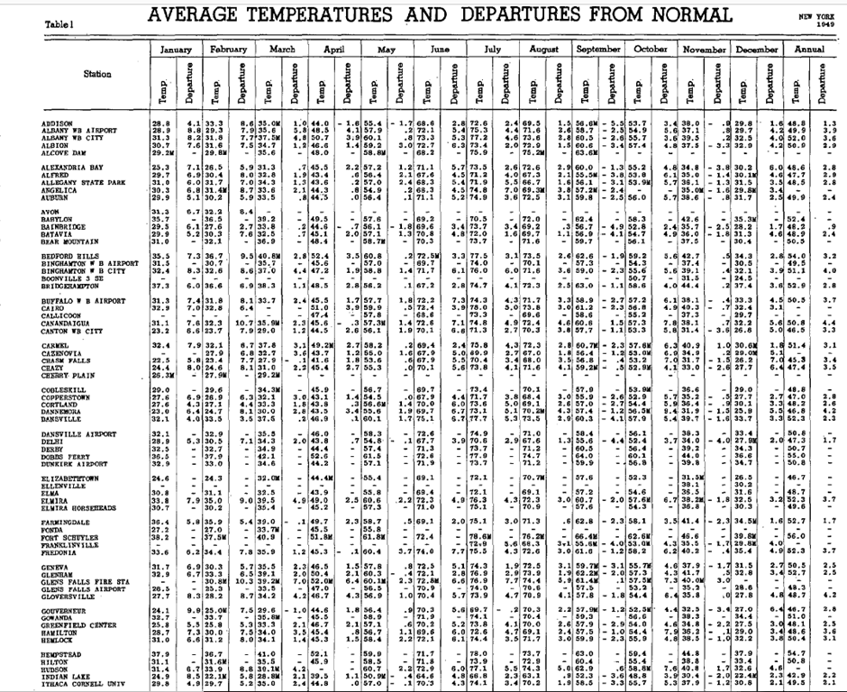
The 49.5 deg F for Ithaca for 1949 is way in the lower right. For 2016, NOAA's annual average temperature for the same Ithaca station read at the same time of day was 48.0 deg F. This is a link to NOAA's 2016 data. You'll have to scroll down a way to find Ithaca temperature data. But anyway, 48.0 deg F is a full 1.5 deg F lower than the 49.5 deg F of 1949. The temperature has gone down, not up -- at least if you compare the original readings for 1949 to the data currently reported for 2016.
But what about the data for this area that make their way into the surface temperature records that support those "hottest year ever" claims that NOAA and NASA regularly release? Those data have of course been subject to large "adjustments." Here is a link to NOAA's "Climate at a Glance" information, with surface temperature data going from the late 1800s to 2017. They don't break these data down to an individual small town like Ithaca, but you can get the small region in which Ithaca is included, namely "New York State, CD10, Central Lakes," that is, the Finger Lakes region of upstate New York. And the answer is, for that small region, the 1949 annual average temperature was 48.6 deg F, and for 2016 it was 48.7 deg F. Instead of going down by 1.5 deg F, the temperature went up by 0.1 deg F! How could that possibly have happened?
Perhaps you might think, this must just be a quirk of the Ithaca station, and the other stations in the small region must have had temperature increases that outweighed the Ithaca decline when the region average was calculated. Homewood has the answer for that as well. His post includes temperature graphs for other main stations in the region -- Auburn, Geneva, and Hemlock -- including "unadjusted" and "adjusted" GHCN data in each case. All of these stations show massive downward adjustments of the temperatures in the earlier years, generally in the range of about 1 deg C (which would be 1.8 deg F), or even more. For example, here is the graph for Geneva:
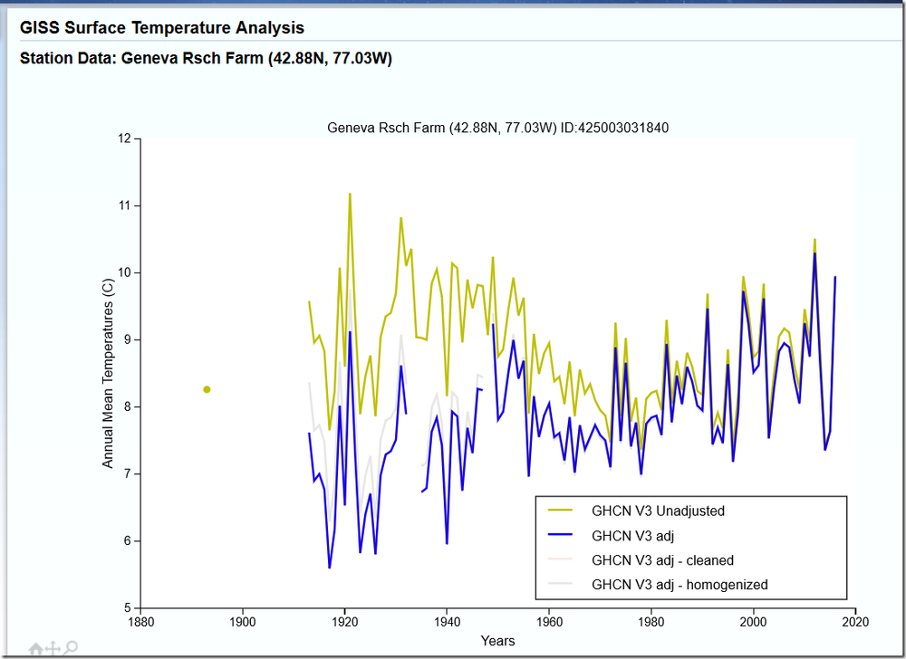
By the way, 1 deg C, or 1.8 deg F, is approximately the entire amount of the claimed warming of the past century that is regularly trotted out to support the narrative that "the earth is warming." Go through the prior seventeen posts in this series, and you will find dozens of other examples of downward adjustments of earlier year temperatures in approximately the same magnitude. No one who has looked into this can find any significant examples of adjustments going in the other direction.
There is more on region CD10 at another recent (January 25) post by Homewood, titled "New York’s Temperature Record Massively Altered By NOAA." This post contains extensive data for all the stations in that region, both unadjusted and adjusted. Homewood decides to compare January temperatures in two particular years, 1943 and 2014. Key quote:
On average the mean temperatures in Jan 2014 were 2.7F less than in 1943. Yet, according to NOAA, the difference was only 0.9F. Somehow, NOAA has adjusted past temperatures down, relatively, by 1.8F.
No one get any kind of satisfactory explanation out of NOAA or NASA as to what is going on. In Part II of this series back in July 2014, I reported on comparable early-year downward temperature adjustments discovered in the state of Texas by Homewood, in Kansas by Anthony Watts of the Watts Up With That website, and in Maine by Joseph D'Aleo of the ICECAPwebsite. Those reports led Politifact to put some questions in writing to NOAA. They received a response, the gist of which was "our algorithm is working as designed" -- without any information as to how or why the specific adjustments were made, nor any access to code or methods to enable the adjustments to be replicated.
At this point it is becoming an embarrassment to the Trump administration that they have not gotten anyone in place at NOAA or NASA who has started to get to the bottom of this.

The Greatest Scientific Fraud Of All Time -- Part XIX
Don’t be too surprised that you’re not reading much recently about the impending climate apocalypse and the supposed “hottest year,” “hottest month,” or “hottest day” ever. The reason is that global lower troposphere temperatures, as measured by satellites and published by UAH, are downby more than 0.7 deg C since early 2016. That’s well more than half of what was thought to be the temperature increase since the satellite record began in 1979. September 2018 turned out to be the coolest September in ten years.
But inquiring minds are still eager to get to the bottom of the temperature adjustment scandal that has created a fake warming trend in the so-called “surface temperature” record that goes back into the mid-1800s. For those unfamiliar with this field, the “surface temperature” record comes from a totally different source from the satellite record, namely a network of conventional thermometers, each located a few feet above the ground, scattered around the world. The data from the surface thermometers is collected and published by three entities, two in the U.S. (NASA and NOAA) and one in England (the Hadley Center at the Climatic Research Unit of the University of East Anglia). Those three use somewhat different but substantially overlapping surface thermometers to compile their records. All three show a noticeable warming trend in the range of 1.5 deg C since the late 19th century.
But is the warming trend real, or is all or most of it an artifact of temperature adjustments made to the record over time? Many have noticed that substantial downward adjustments have been made to raw temperatures recorded at many of the stations in the surface thermometer networks during the earlier part of the record, mainly from the mid-1800s through 1950s. This issue has been the principal focus of my series The Greatest Scientific Fraud Of All Time. This is now Part XIX of that series.
Here’s the new development: A guy named John McLean has just (October 2018) published a big Report via John Boyle Publishing, essentially consisting of an expanded and updated version of his 2017 Ph.D. thesis for James Cook University in Australia. For his thesis, McLean elected to conduct an “audit” of one of the surface temperature records, that of the Hadley Center at UEA, a series known as HadCRUT4. The HadCRUT4 series is the main series relied on by the IPCC for its warnings of climate alarm propounded to the governments of the world. The full McLean Report is behind a pay wall, where it can be purchased for $8. I have purchased a copy. The Executive Summary and some other excerpts can be found at Watts Up With That here.
McLean’s audit is scathing in many respects. He covers everything from impossibly crazy temperature readings that nobody bothers to examine or correct (one town in Colombia records a three-month period with an average temperature over 80 deg C, which is 176 deg F) to ridiculous sparsity of data (in some of the early years, the entire southern hemisphere has only one land-based weather station), and so on. The overall conclusion:
Governments and the United Nations Framework Convention on Climate Change (UNFCCC) rely heavily on the IPCC reports so ultimately the temperature data needs to be accurate and reliable. This audit shows that it is neither of those things.
By all means buy the Report and read it if you have the time. In this post I’m going to focus mainly on one portion of it, which is the part that addresses the issue of the early-year downward temperature adjustments.
For extensive background on this temperature-adjustment issue, you can read the previous posts in this series. To make it a little easier to grasp, I’ll throw in this graph from Part XVIII of the series, posted in January of this year. This graph shows current and earlier versions of temperature data from the station at Geneva in upstate New York. Note that this data is from GISS (NASA) rather than HadCRUT, but the adjustment issues are comparable:
Somehow temperatures prior to 1950 have been adjusted downward by in excess of 2 deg C; and between 1950 and 1970 by in excess of 1 deg C. That’s one way to create a strong warming trend! But how has that been done, and how do we know that the adjustments are appropriate? None of NASA, NOAA or Hadley/CRU have been forthcoming with anything approaching an adequate explanation.
Now McLean weighs in with some insights. From the Executive Summary:
Another important finding of this audit is that many temperatures have been incorrectly adjusted. The adjustment of data aims to create a temperature record that would have resulted if the current observation stations and equipment had always measured the local temperature. Adjustments are typically made when station is relocated or its instruments or their housing replaced.
The typical method of adjusting data is to alter all previous values by the same amount. Applying this to situations that changed gradually (such as a growing city increasingly distorting the true temperature) is very wrong and it leaves the earlier data adjusted by more than it should have been. Observation stations might be relocated multiple times and with all previous data adjusted each time the very earliest data might be far below its correct value and the complete data record show an exaggerated warming trend.
There is much more on this subject in the body of the Report, particularly pages 82 to 86. McLean asserts that something like the following is a frequent occurrence: A measuring site, originally located in an undisturbed rural area, gradually becomes surrounded by urban build-up, and becomes subject to the urban heat island effect. Thus, the temperatures it is recording are “too high,” at least as compared to some theoretical un-affected “true” temperature. At some point, the station is appropriately moved to a new location without the urbanization. The difference between the temperatures recorded at the new and old locations is calculated. And then — and here is the key error — the temperatures at the old location are adjusted downward by the amount of that difference, for all times going back to the beginning of the station. But here’s the error: in its early years, the station was not affected by an urban heat island, so temperatures from that period should not be adjusted downward. Yet they are. From page 84 of the Report:
It is incorrect but seemingly common to apply a constant adjustment to all data from the first site according the calculated difference between it and the second site when the data at the first site has been distorted by gradual changes in the local environment. It defies logic that a location that was abandoned because it was contaminated by external influences was equally contaminated when the observation station was first established there and throughout the entire time that the station was at that site, but this is what a constant data adjustment implies.
So, can an independent researcher at least be given the adjustment methodology so that the process can be reverse-engineered and corrected? From page 82:
Much of the observation station data used in HadCRUT4 is likely to have been adjusted but there is no record of the method used or the amount of the adjustment, which makes the data impossible to independently audit.
In short, there is no getting to the bottom of the temperature-adjustment scandal, because the perpetrators have created no record to make it possible to figure out what they have done or to attempt to reproduce their work.
Final question: Is there any possibility that this is done innocently, as opposed to an intentional effort to engineer a fake record to support the cause of climate alarm?
OK, this is just one young guy doing some due diligence. But the fact is, he has nailed the grand pooh-bahs with obvious data manipulation to achieve their desired result. Do you expect any kind of response from the in crowd? I don’t.
I’ll end with some conclusions from the Executive Summary:
The primary conclusion of the audit is however that the dataset shows exaggerated warming and that global averages are far less certain than have been claimed.
One implication of the audit is that climate models have been tuned to match incorrect data, which would render incorrect their predictions of future temperatures and estimates of the human influence of temperatures.
Another implication is that the proposal that the Paris Climate Agreement adopt 1850-1899 averages as “indicative” of pre-industrial temperatures is fatally flawed. During that period global coverage is low – it averages 30% across that time – and many land-based temperatures are very likely to be excessively adjusted and therefore incorrect.
A third implication is that even if the IPCC’s claim that mankind has caused the majority of warming since 1950 is correct then the amount of such warming over what is almost 70 years could well be negligible. The question then arises as to whether the effort and cost of addressing it make any sense.
Ultimately it is the opinion of this author that the HadCRUT4 data, and any reports or claims based on it, do not form a credible basis for government policy on climate or for international agreements about supposed causes of climate change.

The Greatest Scientific Fraud Of All Time -- Part XX
Since last October, this series has been sitting at the rather awkward number of 19 (or “XIX”) posts. Time to round it off at an even XX.
For those new to this topic, the Greatest Scientific Fraud Of All Time is the systematic downward adjustment of early-year temperatures in order to create a fake enhanced warming trend, the better to bamboozle voters and politicians to go along with extreme measures to try to avert the impending “climate crisis.” Prior posts in this series have documented large and unexplained downward adjustments at hundreds of stations around the world that are used by official government organizations (in the US, primarily NOAA and NASA) to wipe out early-year high temperatures and thereby proclaim that the latest month or year is “the hottest ever!” To read all prior posts in this series, go to this link.
You might ask, with the extensive exposure of these unsupportable downward adjustments of early-year temperatures by official government organizations — accompanied by highly credible accusations of scientific fraud — haven’t the adjusters been cowed by now into a smidgeon of honesty? It sure doesn’t look that way.
The latest news comes out of Australia, via the website of Joanne Nova. Nova’s February 17 post is titled “History keeps getting colder — ACORN2 raises Australia’s warming rate by over 20%.” “ACORN2” is a newly revised and updated temperature series for Australia, with temperatures going back to 1910 based on records from 112 weather stations on the continent, some 57 of which have records that go back all the way to the 1910 start date. “ACORN” stands for Australian Climate Observations Reference Network. The ACORN2 data compilation is so called to distinguish it from ACORN1, which was only released some 7 years ago in 2012. The people who put out these things are the Australian Bureau of Meteorology.
According to Nova, the latest temperature adjustments were released “oh-so-quietly.” I guess that the plan is just to start using the new figures as the historical comparisons and bet that journalists will be too stupid or ignorant to figure out that the earlier temperatures have been altered. That’s actually a pretty good bet. However, down in Australia they do have a hard-working group of independent researchers who are on top of this issue. One of them is Nova, and another is Chris Gillham. Gillham has done his own very detailed analysis of the adjustments in the ACORN2 report, and has also put up a post on same at Watts Up With That. So there is plenty of information out there for intelligent people to make an independent judgment.
A few excerpts from Nova:
Once again we find that the oldest thermometers were apparently reading artificially high, even though many were newish in 1910 and placed in approved Stevenson screens. This is also despite the additional urban warming effect of a population that grew 400% since then. What are the odds?! Fortunately . . ., sorry scientists have uncovered the true readings from the old biased thermometers which they explain carefully in a 67 page impenetrable document. . . . The new ACORN version has nearly doubled the rate of warming in the minima of the longest running stations.
Nova has put together several charts to show the magnitude of the adjustments, not only from ACORN1 to ACORN2, but also from the prior AWAP compilation to ACORN1. To no one’s surprise, each round of adjustments makes the earlier years cooler, and thus enhances the apparent warming trend. Here is Nova’s chart showing the amount of warming from the beginning to the end of the series, for each of AWAP, ACORN1 and ACORN2, and for minimum, mean and maximum temperatures:
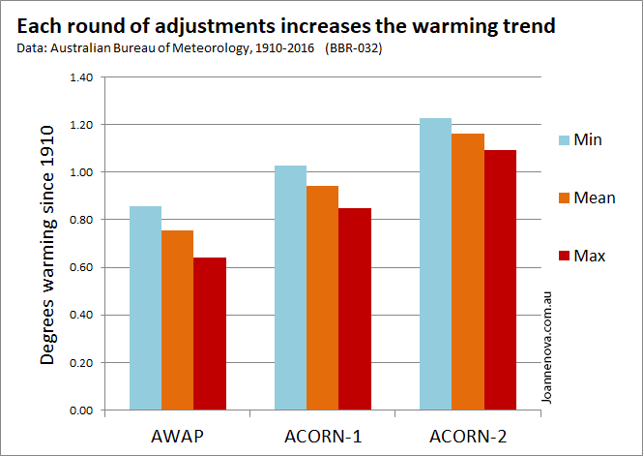
For example, the average minimum temperature had increased over the century covered by 0.84 deg C in the AWAP series. That increased to 1.02 deg C in the ACORN1 series, and to 1.22 deg C in the ACORN2 series.
You need to go over to Gillham’s work to see how these changes derive mostly from decreases in early-year temperatures. Here is a chart from Gillham on the changes to minimum temperatures at the 57 stations that go back all the way to the 1910 start:
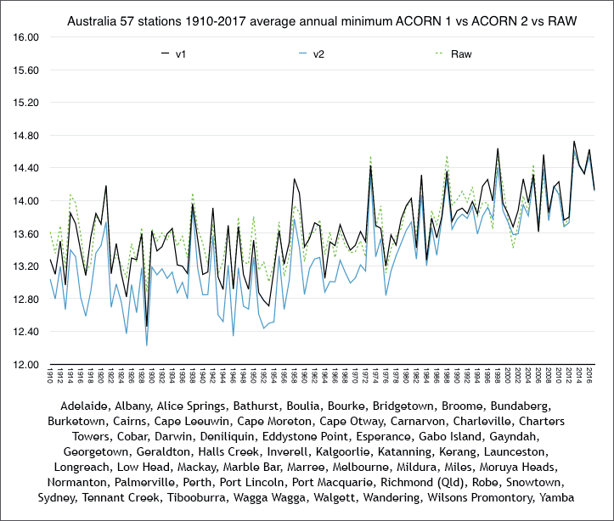
As you can see, the “raw” and “v1” temperatures tend to be close — sometimes one higher, sometimes the other. But v2 is significantly lower across the board in the earlier years. Then, suddenly, in the recent years, it tracks the “raw” almost perfectly.
Do they offer a justification for these downward adjustments? Yes, but nothing remotely satisfactory. The one-word explanation is “homogenization.” OK, we understand what that is. For example, sometimes a station moves, and that causes a discontinuity, where, say, the new location is systematically 0.1 deg C lower than the old. An adjustment needs to be made. But these sorts of adjustments should cancel out. How is it possible that every time some official meteorological organization anywhere in the world makes some of these “homogenization” adjustments, the result is that earlier years get colder and the supposed “global warming” trend gets enhanced — always to support a narrative of “climate crisis.”
Well, fortunately, this time the Australian Bureau of Meteorology has put out a very long 57-page document explaining what they have done. Here it is. Is it any help?
As far as I am concerned, this is the definitive proof of the fraud. If this were even an attempt at real, credible science, the proponents would put out a document complete with the details of the adjustments — and all of their computer code — so that an independent researcher could replicate the work. Nothing like that is here. This is pure bafflegab. Nova calls it “impenetrable,” which is way too nice a word as far as I’m concerned. Let me give you a small taste:
3. HOMOGENISATION METHODS
3.1 Detection of inhomogeneities - use of multiple detection methods in parallel
In version 1 of ACORN-SAT, a single statistical method for detection of inhomogeneities was used (Trewin, 2012). This method was based closely on the Pairwise Homogenisation Algorithm (PHA) developed by Menne and Williams (2009), and involves pairwise comparison of data between the candidate station and all sufficiently well-correlated stations in the region, with the Standard Normal Homogeneity Test (SNHT) (Alexandersson, 1986) used to identify significant breakpoints in the difference series. The test was carried out separately on monthly mean anomalies (as a single time series with 12 data points per year), and seasonal mean anomalies, with a breakpoint flagged for further assessment if it was identified in either the monthly series, or (within a window of ± 1 year) in at least two of the four seasons. Further details of the implementation of the PHA in the ACORN-SAT dataset are available in Trewin (2012).
A range of other detection methods have been developed in recent years, many of which were the subject of the COST-HOME intercomparison project (Venema et al., 2012). Three of these methods were selected for use in ACORN-SAT version 2, the selection primarily based on ease of implementation. These methods were:
- • HOMER version 2.6, joint detection (Mestre et al., 2013)
- • MASH version 3.03 (Szentimrey, 2008).
- • RHTests version 4 (Wang et al., 2010).
All of these methods, which use different statistical approaches, have been successfully used across a range of networks since their development. Further details on their implementation are given in Appendix C.
My favorite part is that reference at the end to “Appendix C.” This document has no Appendix C. There are three appendices, numbered Appendix 1, Appendix 2 and Appendix 3. That’s about the intellectual level we are dealing with.
Anyway, try going to this document and see if you can figure out what they are doing. Believe me, you can’t.
And finally: over the years as I have accumulated posts on this topic, several commenters have suggested that I must be alleging some kind of conspiracy among government climate scientists in making these adjustments. I mean, without that, how does it come about that the Australians just happen to be making the exact same kinds of adjustments as NASA, NOAA, and for that matter, as the Brits at the Hadley Center in the UK?
If your brain is wondering how that could be, I would suggest that we have the same kind of phenomenon going on here as the hate crime hoax phenomenon. How does Jussie Smollett just happen to fake a hate crime playing right into the progressive narrative of the moment — just as did the Duke lacrosse team hoaxer, and the Virginia fraternity hoaxer, and the Harvard Law School black tape hoaxers, and many dozens of others? (Here is a compilation of some 15 recent hate crime hoaxes.) Did they all coordinate in one grand conspiracy? Or did they all just realize what was needed from them to support their “team” and its narrative?
DEAR READERS: I have no idea why this piece has been formatted in two columns. I’ll try to fix it tomorrow.
UPDATE, February 20: I think I fixed the problem.

The Greatest Scientific Fraud Of All Time-- Part XXI
Just a few days ago (February 19), I posted part XX of this series. The subject of that post was a new compilation of historical temperatures for Australia (going back to 1910), known as ACORN2, just out from the Australian Bureau of Meteorology. The effect of ACORN2 was to increase the reported rate of climatic warming in Australia by 0.2 deg C per century over the previous compilation known as ACORN1, which had only been issued about 6+ years ago and had itself also increased the reported rate of warming as against the previous official records by about 0.2 deg C per century. The increased rate of warming is entirely accomplished by adjusting earlier-year temperatures downward.
Could there possibly be anything honest about what is going on? My source for the February 19 post — independent Australian researcher and blogger Joanne Nova — provided a link to the the BoM’s 57-page Research Report that supposedly justified the changes. That document appeared “impenetrable” both to Nova and to me, but maybe some much cleverer person could figure out what they were doing?
Well, now we move to the next step. Another hard-working Australian independent researcher and blogger, Jennifer Marohasy, decided to get the detailed records for a particular station, just to see what adjustments had been made, and whether any possible legitimate explanation could support them. The station that Marohasy selected is Darwin. For those unfamiliar with the geography of Australia, Darwin is the biggest city (not very big — about 150,000 people) in the vast northern areas of the country. Marohasy’s February 23 post is titled “Changes to Darwin’s Climate History are Not Logical.” A version of Marohasy’s post was also published on Watts Up With That on February 22.
Basically, Marohasy documents that Australia’s BoM has shortened Darwin’s temperature record to begin in 1910 (records actually exist back to 1895), and then adjusted the earliest temperatures downward by a full degree and more C, just since the previous set of downward adjustments only 6 years ago. For example, here is what has happened on the first day of the series as it now exists:
[O]n 1st January 1910 the maximum temperature recorded at the Darwin post office was 34.2 degrees Celsius. A few years ago [in ACORN1], the Bureau changed this to 33.8 degrees Celsius, cooling the recorded temperature by 0.4 degrees. In its most recent re-revision of Darwin’s climate history the temperature on this day has been further reduced, and is now just 32.8.
And of course, it’s not just the one day. Let’s look at the first six days of January 1910:
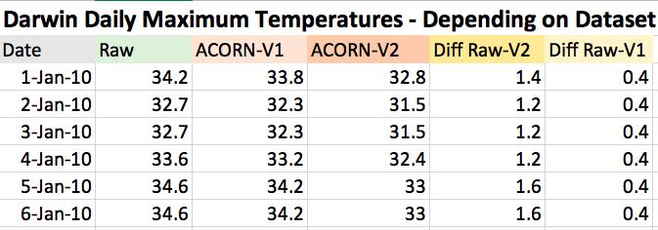
All of them got adjusted down by something in the range of 0.8 to 1.2 deg C, even after prior downward adjustments just 6+ years ago. The environmental reporter for the newspaper The Australian asked the BoM for an explanation, and here is what he got:
For the case of Darwin, a downward adjustment to older records is applied to account for differences between the older sites and the current site, and differences between older thermometers and the current automated sensor. In other words, the adjustments estimate what historical temperatures would look like if they were recorded with today’s equipment at the current site.
But here’s the problem, idiots: this is the same explanation you gave six years ago for the 0.4 deg C downward adjustment then. What about temperatures in the year 1910, or the equipment in 1910, or the site in 1910, changed between ACORN1 in 2012 and ACORN2 in 2019 to justify further downward adjustments averaging a full deg C? Nothing. Marohasy:
Neither the equipment, nor the site has changed since ACORN-SAT Version 1 was published in 2012. Yet another 1 degree has been shaven from the historical temperature record! To be clear, the weather station has been at the airport since February 1941, and an automatic weather station was installed on 1 October 1990. A Stevenson screen was first installed at the post office site in 1894, and has always been used at the airport site. So, why was the temperature dropped down by a further one degree for 1 January 1910 in the most recent revision – undertaken just a few months ago? There is no logical or reasonable explanation.
Are you still wondering if there is anything honest about this? Marohasy compiles a graph of the raw mean maximum annual temperatures as recorded at Darwin, versus the “adjusted” ACORN2 series that is now Australia’s official temperature record. Note that the site did move in 1941, from the post office in downtown Darwin out to the airport. To indicate the discontinuity, Marohasy graphs the post office series in green, and the airport in blue. Here is her graph:
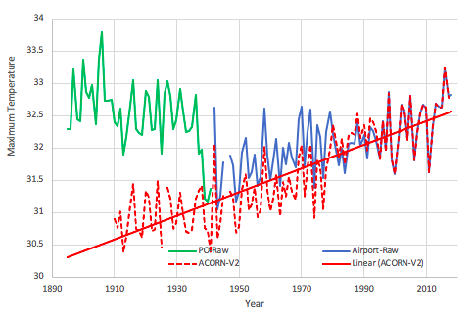
Is the post office site systematically warmer than the airport site? Note that the last several years at the post office were considerably cooler than the first years at the airport. But the BoM has made the executive decision to replace the temperatures recorded at the post office in the period 1910 to 1941 with temperatures that average about 1.5 deg C cooler. Pre-adjustments, 1906 looks like the year with the hottest mean maximum temperature, and by a wide margin; and number two is also pre-1910. Post-adjustments, the warmest is 2016. This is how you get to have “hottest year ever” press releases every year or two.
Conclusion, from Marohasy:
What the Bureau has done to the historical temperature record for Darwin is indefensible. The Bureau has artificially shortened and cooled Darwin’s climate history to make it consistent with the theory of human-caused global warming.
It’s completely dishonest and fraudulent.
For all 21 posts in this series, go to this link.

The Greatest Scientific Fraud Of All Time -- Part XXII
My post from Sunday, which was Part XXI of this series, achieved a record number of readers for any of my posts — around 100,000 and counting — and has 50 comments so far. Thanks to all who have taken the time and effort to comment. Many of the comments are thoughtful and insightful, which I greatly appreciate. Several commenters express doubt or skepticism as to some or all aspects of the post. Being a lover of all doubt and skepticism, I thought it would be worthwhile to respond to some of these questioners.
Several commenters point out that Part XXI discusses only one temperature station — Darwin, Australia — out of about two thousand that are used to produce the world’s official temperature records. For example, Shawn comments:
Ok that's one station one sample over time,, can u do the same for all the other stations around the world.
And NorEastern comments:
The problems with any single point analysis are numerous.
1: Adjustments because of sensor changes are opaque to everybody without an electrical engineering degree. We, the public, cannot evaluate adjustments because we do not have the needed expertise and the device specs.
2: There are tens of thousands of sensors distributed across the globe. . . .
My first recommendation to such questioners is that they read Parts I through XX of the series. If you do that, you will quickly find out that this is not about just one station, but hundreds, if not every single one of the 2000 or so (not “tens of thousands”) that make up the world’s official surface temperature records. For example, the very first post of the series, from all the way back in July 2013, compared two graphs put out by NASA covering historical temperatures for the U.S. The U.S. has something in excess of 1000 stations contributing to the record, around half of the world total, and is generally thought to have the best surface temperature records of any country in the world. One of the NASA graphs covered in my post was published in 1999, and the other in 2011. In the 1999 graph, the warmest year is 1934, and the second warmest is 1921. In the 2011 graph, the earlier years have been adjusted downward, and the warmest year has become 1998. That first post also contains a comparison of raw and currently-reported temperatures for the very prominent weather station at Central Park in New York City. Earlier year temperatures there had been adjusted downward by an average of 1+ deg F, and up to about 2 deg F. (There have since been additional downward adjustments of the early years.)
Part II of the series, from July 2014, introduced readers to the work of Tony Heller. Heller is truly the guru of this subject (that is, data tampering of the official temperature records). His work covers thousands of stations, not by any means just one or a few. Here is a link to a representative piece of Heller’s work, this one covering all U.S. stations (again, over 1000, and about half the world total). This post of Heller contains one of his iconic graphs, demonstrating the cumulative effect of downward adjustments on U.S. temperature history:
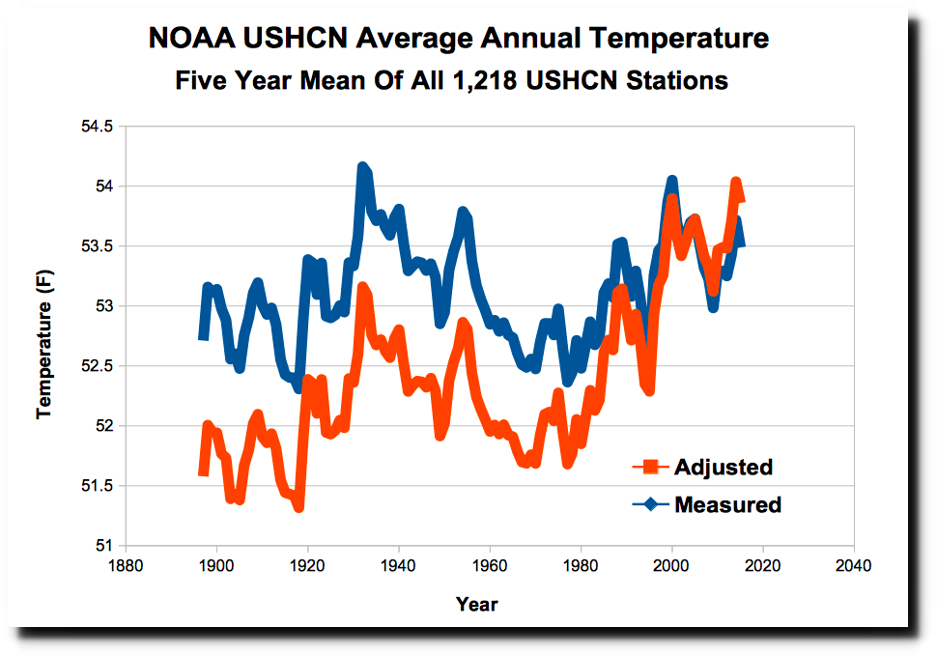
As my series has progressed, I have attempted to provide a good mix of posts that focus on one or a small group of stations with inexplicable and unjustifiable downward temperature adjustments, with other posts that cover large numbers of stations. For example, Part III focused on the stations in the nation of Paraguay in South America; Part VI focused on an overall comparison of the thermometer (“surface temperature”) records with satellite records of the same time period (thus, essentially covering all stations in the world); Part XII focused on a certain station in Connecticut with which I am personally familiar; and so forth.
Another commenter, gkam44, posts this recommendation:
Go here and look at the data and the graphs of real numbers.
gkam44 then provides a link to temperature graphs that appear in the IPCC’s latest “assessment report,” that came out back in 2013. For example, here is a key one from among the graphs at gkam44’s link:
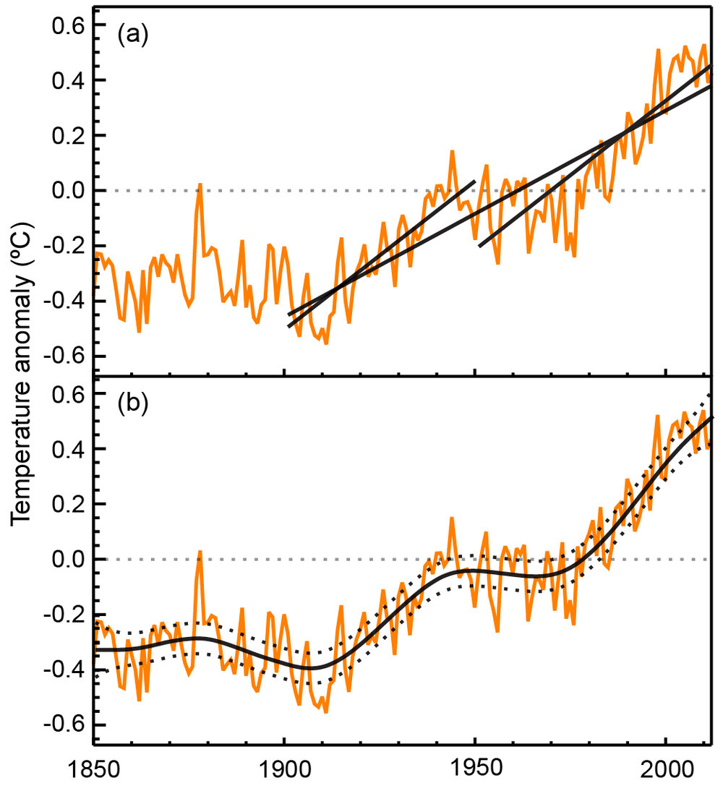
Here’s the problem, gkam44: These graphs derive precisely from the surface temperature record that has been adjusted downward in the early years. The IPCC does not even so much as acknowledge the issue. Sorry, but with the enormous evidence of data tampering now out there, no reasonable person is going to accept these graphs only on the basis of the authority of the proponent.
And finally, commenter Peter picks up on my use of the term “impenetrable” to describe the Australian BoM Report describing the basis for its adjustments:
When you admit that a scientific report is "impenetrable" to you that's a good sign you don't know what you are talking about in this field and should not brave to wade into the discussion.
I had picked up the term “impenetrable” from Joanne Nova, who had also used it to describe the Report. Perhaps it was not the best term for my purpose. What I really mean to say about the Report is that on its face it is not science. “Science,” as I understand the term, has several bare minimum requirements. First, to qualify as science, work must address a hypothesis that is falsifiable. Second, to qualify as science, work must be replicable, and all data and methods (including computer code) needed to replicate the work must be disclosed. Despite its great length and use of official-sounding jargon, this BoM Research Report does not contain the fundamental information to meet those two bare minimum requirements. Therefore it is not science. It shares that characteristic with the entire field that falsely calls itself “climate science.”

The Greatest Scientific Fraud Of All Time -- Part XXIII
The scandal that I call “The Greatest Scientific Fraud Of All Time” is the alteration of official world temperature data by a small number of government employees in the US and the UK. Uniformly, the alterations have the effect of lowering temperatures early in the record, and raising recent temperatures, in order to create and enhance a warming trend that does not exist in the data as originally reported. The purpose of the fraudulent data alteration is to support the continuation of the “global warming” climate scare. To read the prior 22 posts in this series, go to this link.
Despite what you might think from reading the mainstream press, the past few years in world temperatures have not been particularly good for the continuation of climate alarm. No matter how you measure them (the main methods being ground thermometers, weather balloons, and satellites), world atmospheric temperatures have gone down for more than three years since a peak reached in early 2016. The data set that I consider to be the most reliable — the satellite-based measurements from the University of Alabama at Huntsville — gives the global temperature “anomaly” for the most recent month (June 2019) as +0.47 deg C. That is well down from the peak of +0.88 deg C in early 2016, and represents a decrease of about a third of what had been the entire increase since the satellite record began in 1979. Here is the most recent UAH global lower atmosphere temperature graph:
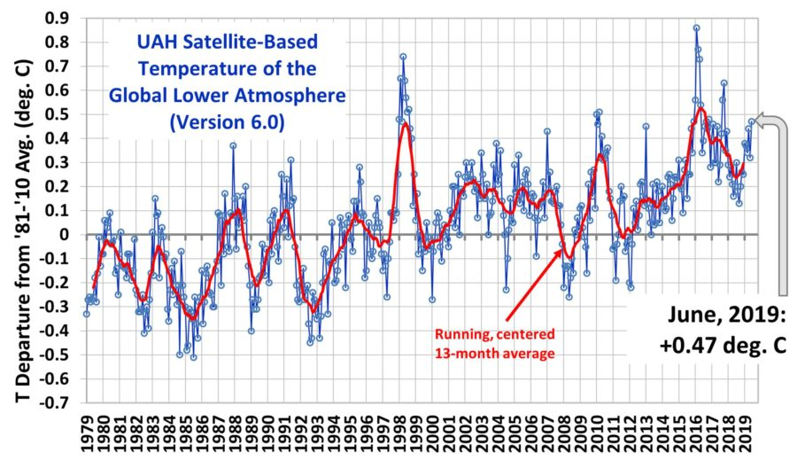
The failure of temperatures to continue to rise in accordance with alarmist model predictions has left the alarm-promoting guys at NASA and NOAA without fodder for their former annual “hottest year ever!!!” press releases. From the NASA end-of-year-2018 release:
2018 Was the Fourth Warmest Year, Continuing Long Warming Trend. . . . The 2018 global temperature average ranks behind 2016, 2017, and 2015.
I leave it for you to figure out how a year that was down from 2017, which in turn was down from 2016, somehow “continues[es] [a] long warming trend.” In a real “long warming trend,” shouldn’t each year be successively warmer than the previous year?
So what is to be done? Readers of this series will not be surprised to learn that in this period where not so many people are looking, the temperature adjusters have been beavering away in the bowels of their collections of data, continuing to send inconvenient readings of the past down the memory hole, and to “adjust” the temperatures of the past down, and of the present up. Let me provide a small roundup of some things that have been discovered recently.
At NoTricksZone on June 25, Pierre Gosselin posts some work by a Japanese guy named Kirye. Kirye is a Japanese climate skeptic Twitter-blogger, but his Twitter page is in Japanese, so you probably won’t be able to read it. Kirye noticed that NASA came out on June 14 with a new version, version 4, of its surface-thermometer-based temperature series known as GISTEMP. GISTEMP v.4 is now based on the records of the also-newly-adjusted Global Historical Climate Network group of temperature stations, now called GHCN v.4. Kirye then analyzes the new data from NASA at six particular and widely-scattered weather stations: Punta Arenas, Chile; Marquette, Michigan; Port Elizabeth, South Africa; Davis, Antarctica; Hachijojima, Japan; and Valencia, Ireland.
Sure enough, there have been additional adjustments, as always in the same direction — older down, and newer up. But those adjustments between v.3 and v.4 have been relatively minor. More significantly, Kirye discovered a different maneuver which is even more incredible, and which he proves by direct links back to NASA’s own website: In the v.4 graphs that it provides, NASA has relabeled the hugely-adjusted v.3 data as “unadjusted.”
I’ll go in detail through just one of the sites for purposes of illustration. I pick Marquette, Michigan. The NASA graph for v.3 for that site can be found at this link. That graph shows both “unadjusted” and “adjusted” temperatures. The “unadjusted” graph shows a temperature peak in the 1930s followed by a substantial cooling trend since. The v.3 adjusted temperatures closely match the unadjusted in the recent years; but in the early years (1880 even to the 1970s) there are dramatic downward adjustments, averaging over 2 full deg C, thus creating a strong artificial warming trend. Then go to the brand-new NASA v.4 graph for the same site. The series that was labeled as “adjusted” on the v.3 graph has now been relabeled “unadjusted,” as a prelude to some further adjustments (which are less dramatic than the previous ones but still up to 1 deg C).
Kirye provides an animated comparison of the NASA v.3 and v.4 “unadjusted” temperature series. A small cooling trend in the v.3 unadjusted series has been turned into a strong warming trend in what is called v.4 “unadjusted” series (but is actually the v.3 adjusted series).
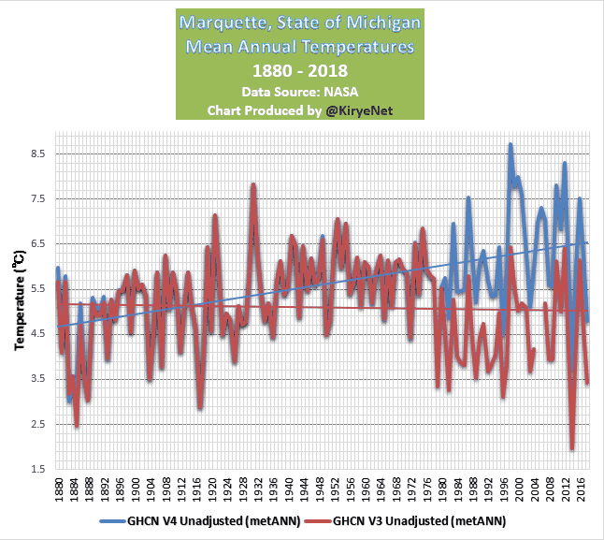
You can go to the links for the NASA graphs and verify that Kirye has accurately copied what they have done. Amazing. The exact same thing occurs at each of the five other sites, although the magnitude of the change in trend is not as great at the other sites. However, although the magnitude of the change in trend may vary, the direction of the change in trend created by the now-memory-holed “adjustments” is always the same — the warming trend is enhanced.
Another data point for today comes from the UK and from an independent blogger named Clive Best. Best reminds us that back in the period 1998 to 2013, there was something called the “hiatus,” where world temperatures failed to rise for a full 15 years despite ongoing calls for climate alarm. One of the data sources supporting the existence of the “hiatus” at the time was a UK-based surface temperature series called HadCRUT, coming from the Hadley Center at the University of East Anglia. In a post on June 24 titled “What Ever Happened To The Global Warming Hiatus?”, Best traces “adjustments” to the HadCRUT data series that have occurred in recent years. Turns out that in a series of seemingly very small adjustments, the “hiatus” has been completely erased. In the most recent data release, the years 2005, 2010 and 2014 have all suddenly turned out to have been warmer than 1998, although recorded at the time as cooler. Here is Best’s graph:
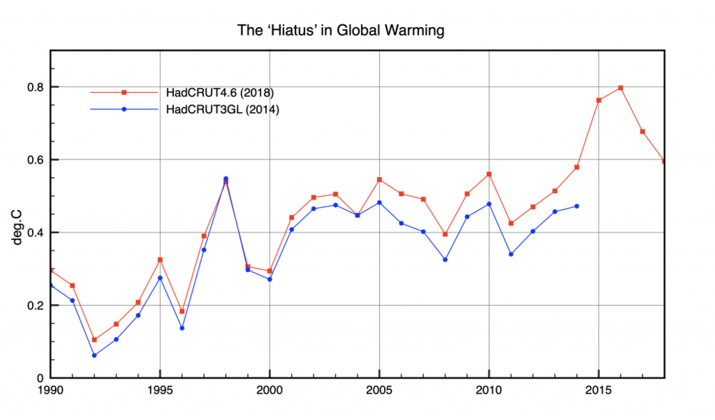
Funny that once again, each one of the adjustments somehow enhances the warming trend. Is it really possible that never once does any new data, or adjustment to data, lead to a change in the other direction?
And finally, over at the site Climate Scepticism on June 30, Paul Matthews notices that the Hadley guys have also recently come out with a new version of their sea surface temperature series, HadSST4. And how does this v.4 compare to the superseded v.3? I’ll bet you can’t guess:
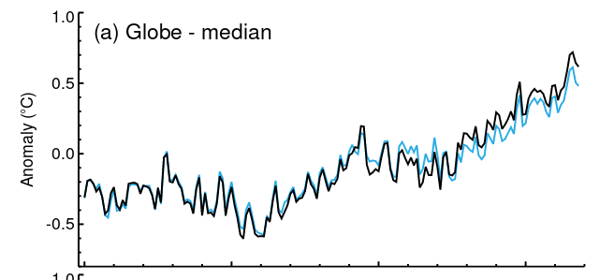
Matthews points out the the larger tick marks on the graph are for 1850, 1900, 1950 and 2000. Anyway, just this most recent adjustment has added about 0.1 deg C to the claimed temperature increase. It may not seem like much, but remember, they “adjust” these things regularly, and every adjustment results in a little bit more of the ongoing artificial enhancement of the supposed warming.

